Resume of

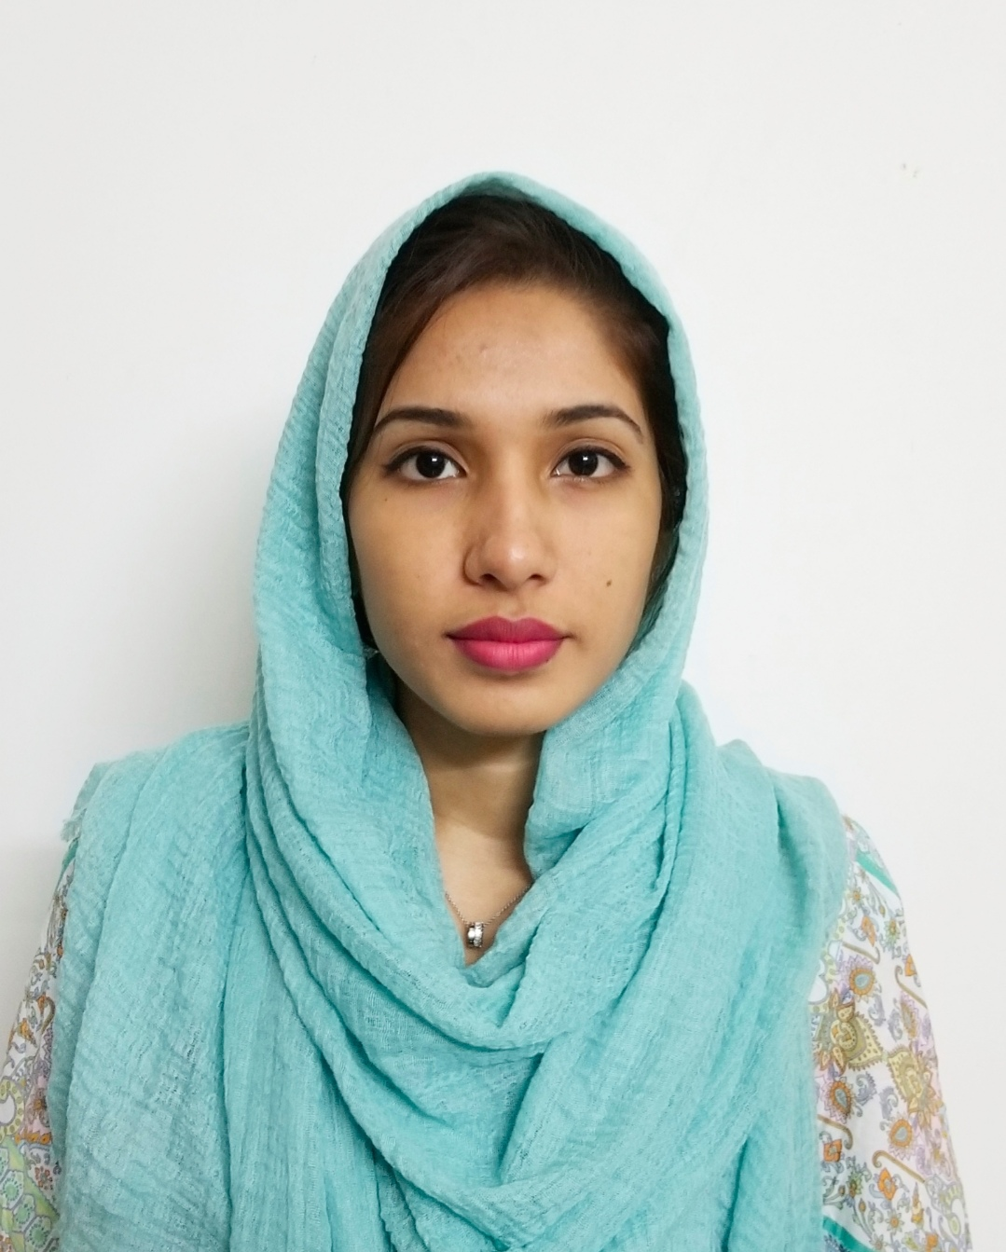

FAHMIDA SULTANA TANIA

AKASH, Sebok 3, 1st floor, East Mirabazar, Sylhet-3100
Cell No. +8801775656469
E-mail: taniayehyea@gmail.com

OBJECTIVE
To obtain a responsible position through which I can utilize my knowledge, unlock my potentiality, and enhance my skills as well as can acquire the ability to face a high level of challenges, and at the same time I would like contribute my best to the organization.

ACAMEDIC QUALIFICATIONS

Graduate :BA (honours)

Subject : Philosophy.

CGPA : 2.83 on a 4.00 point scale

Year : 2017

Moulvibazar Government College,

Under National University.

HSC : Group : Humanities

Board :Sylhet

GPA. : 4.00 on a 5.00 Point Scale
Year : 2013
Moulvibazar Government College
Moulvibazar 3200

SSC : Group: Humanities
Board : Sylhet
GPA : 4.25 on a 5.00 Point Scale
Year : 2011
Shah helal high school
Moulvibazar 3200

COMPUTER LITERACY
- Knows how to use PC/Laptop and mobile applications by using smart phone

LANGUAGE PROFICIENCY
- Fluent in Bengali & English and also understand Hindi

SELF ASSESSMENT
- Strong analytical ability and communication skills.
- Comprehensive creative thinking and fast learning capacity.
- Efficient in teamwork and ready to accept challenges.

INTEREST IN
- Participating in creative works.
- Reading novel, watching TV, traveling and listening music, chatting via FB, WhatsApp etc.

PERSONAL DETAILS
Father’s Name : Muhammed Badrul Islam
Mother’s Name : Shibly Islam Chowdhury
Present Address : AKASH, Sebok-3, 1st floor, East Mirabazar, Sylhet
Permanent Address :
Village:Jakandi,P.O. Dashkahonia,P.S. & Dist:Moulvibazar-3200
Date of Birth : November 19, 1994
Religion : Islam
Nationality : Bangladeshi
Marital Status : Married
Blood Group : B+ (positive)

REFERENCEE:
1.
Name : Muhammed Badrul Islam
Business Development Manager,
Education@
Consulting Firm
Sylhet branch.
Contact No : 01715721446
Email: badrulislam650@gmail.com
2.
Name : Md. Humayun Rashid
Executive officer
Mercantile Bank Limited,
Sylhet branch.
Contact No: 01712319419
Email: rajuhumayun@mblbd.com

I, hereby, declared that the information given above is true, fair and fully updated.

____________________________

FAHMIDA SULTANA TANIA

