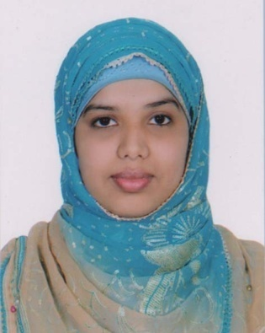
Curriculam Vitae

Tanvir Alom
Gugarkul, Golapganj, Sylhet
Mobile: 01772598977
Email: Tanviralomgd@gmail.com

Career Objective:

Searching for responsibilities & Opportunities in those where academic background & skill can be exercised & fields of interests also synchronized in order to develop, extend & upgrade my carrier. I am willing to serve under a disciplined atmosphere and uniform.
Educational Qualification:

Degree (Hon’s) National University Gazipur, Bangladesh
Program : Department of English (4th year running)
Institution : Dhakadaskhin Govt. College
Higher Secondary Certificate (H.S.C) 2years
Institution : DhakaDakin Multilateral High School & College
Board : Sylhet
Group : Humanities
Result : Grade point Average 3.42
Year of Passing : 2016
Secondary School Certificate (S.S.C) 10 years
Institution : Golapgonj Jamia Islamia High School
Board : Sylhet
Group : Humanities
Result : Grade Point Average 4.00
Year of passing : 2014
Language Proficiency

Bengal : Native Language
English : Medium of instruction was English at The honour’s Level and English was compulsory subject at the H.S.C & S.S.C level. Have good command over English language both in Speaking & writing.

Computer Literacy:

Software Application : MS Office (Word), Graphics Designer done by The IT Aid Academy.
- Ability to work with people of multiple nationalities and culture.
Individuality:
- Possess excellent writing and oral communication skills in English.
- Skilled in analytical problem solving and is able to grasp new concept quickly.
- Self motivated to learn and to take responsibility.
Extra Activities:
- Good presentation skills
Personal Information:

Name : Tanvir Alom
Father’s Name : Noor Miah
Mother’s Name : Fatema Begum
Permanent Address : Vill: Gugarkul, P.O: Ronkeli North, P.S: Golapganj, Dist:Sylhet
Date of Birth : 02 March 1997
Nationality : Bangladeshi
Religion : Islam
Marital Status : Unmarried

Reference:

Date: Tanvir Alom

