Tahlil Ahmed Chowdhury
Address: House no- Bithika A 12/1, Flat No- 04, Noyapara, Lama Bazar, Sylhet.
Cell: 01991-779767 or 01671-623750
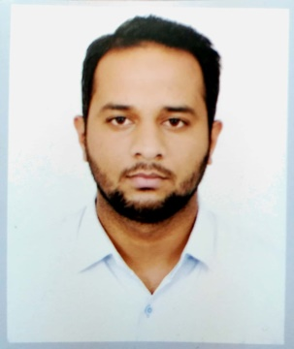
E-mail: tahlilahmed680@gmail.com

Career Objective

To remain embarked on the challenging career-path of business administration in environments where experience can be leveraged, used and enhanced to increment knowledge, and complement the analytical and implementation skills in organizations focused on adding value to the business.

Employment History

- Rancon Autos Limited
Key Account Manager (Sept 03, 2018- Jan 31, 2019)
Department: Sales & Operations
Job Location: Sylhet

- LankaBangla Finance Limited
Senior Executive (Mar 19, 2018- Aug 30, 2018)
Department: Sales
Job Location: Sylhet

Academic Qualification
Exam Title | Concentration/ Major | Institution | Result | Passing Year
BBA | Accounting & Information System | Leading University | 3.08 | 2014
HSC | Science | Scholarshome | 4.00 | 2009
SSC | Science | Kasim Ali High School | 3.88 | 2007

Key Skill’s
- Proficiency in the use of Microsoft Office applications ( i.e. MS Excel, MS Word & Power Point)
- User friendly with all operating environment like Windows 7,8,10 along with Linux.
- Analytical and detailed-oriented, able to identify and implement process improvements that increase accuracy, consistence and efficiency.

Language Proficiency
IELTS (Academic) Overall band Score: 7.0

Personal Details
Father’s Name | Khaled Ahmed Chowdhury
Mother’s Name | Bapin Nahar Chowdhury
Date Of Birth | January 21, 1991
Gender | Male
Marital Status | Single
Permanent Address | Vill- Fulbari, Thana- Golapganj, Dist.- Sylhet.
Reference
Reference 01 | Reference 02

Name: Md. Mahbubur Rahman | Name: Safwan Bin Hussain
Organization: Leading University | Organization: Rancon Autos Ltd.
Designation: Assistant Professor | Designation: Zonal Business Manager
Address: Ragibnagar Sylhet | Address: Mirabazar, Sylhet
Cell: 01717-019305 | Cell: 01701-211887

Declaration
I hereby declare that the above information is true to the best of my knowledge and brief.

……………………….

