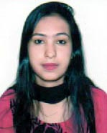
Contact Info:
Taki Ashrafi Binte Shahab
39, Showdagortula, Kumarpara Sylhet
Cell: +8801795169252
Email: thakiashrafi@gmail.com

curriculum vitae
Of
Taki Ashrafi Binte Shahab

To achieve a successful career through integrity and ethics, sincerity, devotion, commitment, team work, learning, continuous improvement and maximum utilization of available resources. To establish myself as an efficient worker to meet the challenges of globalization in today’s era of business.

Objective

Bachelor of Arts (English)

Education

Institution : Metropolitan University, Sylhet
Education Year : 2014 – 2018
Department : English
Result : 2.93 (Out of 4.00)

Higher Secondary School Certificate (H.S.C)
Institution : Dhakadakshin M. L. High School & College.
Passing Year : 2013
Group : Humanities
GPA : 4.10 (Out of 5.00)
Board : Sylhet.

Secondary School Certificate: (S.S.C)
Institution : Dhakadakshin M. L High School & College.
Passing Year : 2011
Group : Science
GPA : 4.56 (Out of 5.00)
Board : Sylhet.

Language
Skills

Language | Standard/Level of Proficiency
Bangla-Reading, Writing and Speaking | Excellent
English-Reading, Writing and Speaking | Good

- Microsoft Word.

Computer
Skills

- Microsoft PowerPoint
- Microsoft Excel
- Microsoft Access
- Internet browsing.

Experience

- Part Time English Lecturer of Dhakadakshin degree College

Skills

- Interpersonal & Communication Skill, and Managing Skill.

Interest

- Interested in Travelling, Outing, Family
- Spending time with Social Works

Name : Taki Ashrafi Binte Shahab

Personal Information

Father’s Name : Shahab Uddin Ahmed
Mother’s Name : Nazma Shahab
Date of Birth : 30th May 1995
Place of birth : Sylhet
Gender : Female
Religion : Islam
Marital Status : Single.
Nationality : Bangladeshi.
Contact No. : +8801795169252
Present Address : 39, Showdagortula, Kumarpara Sylhet
Permanent Address : Raygorh. Dhakadakshin, Golapgonj, Sylhet
Professor Dr. Suresh Ranjan Basak
Dean of Humanities Department
Metropolitan University, Sylhet
Cell No: 01712045327

Anik Bishwas

Reference

Assistant Professor & Head
Department of English
Metropolitan University, Sylhet
Cell No: 01717555391

Declaration

I there by declare that the above statements furnished by me are true to the best of my knowledge and belief.

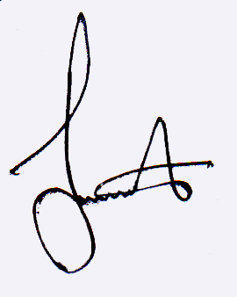

……………………….
Taki Ashrafi Binte Shahab
Date:

(Tripti Debi)
Date...

