KHONDOKER ABDUR ROB  BIN ASADUR RAZA  Email: khondokertaki@gmail.com  Phone number: +8801711904892  Address of Correspondence  17 Blue Eye Tower, Borobazar,  Amborkhana, Sylhet 3100 | 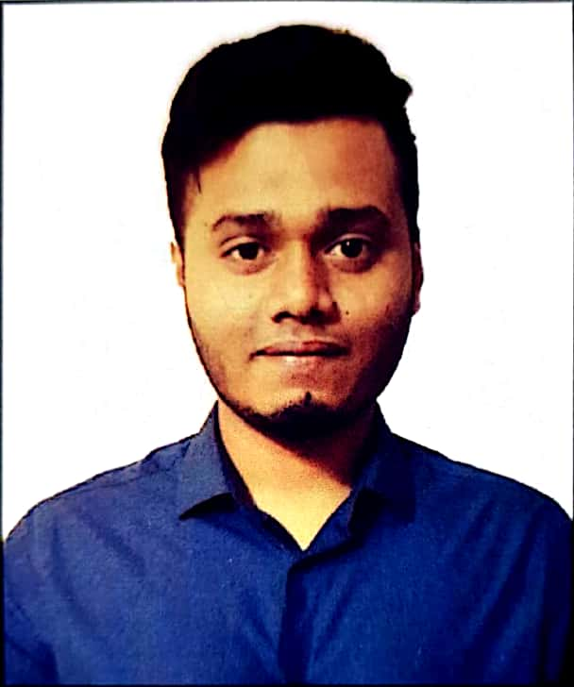

Career Objective

To secure a responsible career opportunity to fully utilize my training and skills, while making a significant contribution to the success of the company.

Educational Background

- Masters of Arts (M.A.)
Duration : 2018-present
Institution : North East University Bangladesh
Department : English

- Bachelor of Arts (B.A.)
Institution : North East University Bangladesh
Department : English
Session : 2015-201
cGPA : 2.69in scale of 4.00

- Higher School Certificate (HSC)
Institution : The Royal M.C Academy
Group : Business Studies
Session : 2012-2013
Passing Year : 2014
GPA : 4.10 in scale of 5.00

- Secondary School Certificate (SSC)
Institution : Border Guard Public School and College, Sylhet
Group : Business Studies
Session : 2010-2011
Passing Year : 2012
GPA : 4.06 in scale of 5.00

Language Skills

Fluent in both Bangla and English for written and verbal communication.

Computer Skills

Software Skills: Proficient in Microsoft Word, Microsoft Power point, Microsoft Excel.

Personal Details

Full Name : Khondoker Abdur Rob Bin Asadur Raza
Father’s Name : Khondoker Asadur Raza
Mother’s Name : Rebeka Parvin Chowdhury
Date of Birth : 19th August, 1996
Gender : Male
Blood group : O + (Positive)
Marital Status : Unmarried
Religion : Islam
Nationality : Bangladeshi (by birth)
Present Address : 17 Blue Eye Tower, Borobazar, Amborkhana, Sylhet 3100
Permanent Address : 17 Blue Eye Tower, Borobazar, Amborkhana, Sylhet 3100

References
Muhammad Shamsul Kabir  Assistant Professor & Head  North East University Bangladesh  Mobile: 01819560206 | Murtaz Ahmed Chowdhury  Assistant Headmaster  PDB High School Bagbari, Sylhet  Mobile: +8801715389305

