MD. MOYNUL ISLAM TANMOY 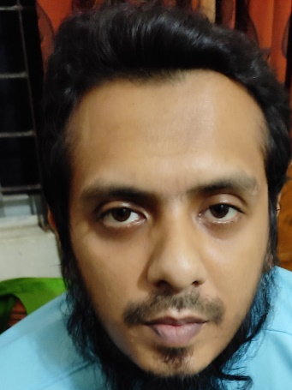

Mailing Address:
15/C/3, 5-B, Mirbagh
Moghbazar Dhaka -1217
Cell No: 0167-0892124
Email: tanmoyzodiac@gmail.com

Career Objectives
Want to build up a challenging and rewarding career in banking industry or financial institution prioritize in capital market where I can deploy my experience and motivation for achieving organizational goal.

Job Experience
- Officer, Securities Services
(From October 08, 2013 to February 25, 2016)
Standard Chartered Bank
Level-6, Portlink Tower, SCB House
67 Gulshan Avenue, Dhaka-1212

- Assistant Officer, One Stop Service
(From April 08, 2017 to April 14, 2018)
IFIC Bank Ltd.
Bagerhat Branch, Sadhonar More
Bagerhat.

- Key Responsibilities in Standard Chartered Bank
- Account opening for custody clients which also includes BO account.
- Preparing Invoice for global custodian
- Opening new stock
- Client service, Respond query regarding MFA or Billing.
- Nostro & GL account Reconciliation.
- Securities Settlement activities for clients.
- Corporate Actions Activities
- Representing foreign client’s shareholders meeting.
- Archival Management.
- Key Responsibilities in IFIC Bank Ltd.

- General Banking, Cash reconciliation
- Opening Personal A/C, Fixed Deposits
- Archival Management
- Transfer Fund to Fund A/C
- Main activities related to one stop service
- Receipt cash, Payment cash
- Consumer related solution regarding any question related with one stop service

Training Program on Securities Laws of Bangladesh

- Participated in Training Program on Securities Laws of Bangladesh
Held during 05 April-19 April 2015 by BICM (Bangladesh Institute of Capital Market)

Training Program on Sonali life insurance company limited

- Participated in Microsoft office and PC fundamentals with pass from 10th February to 19th February at Sonali life insurance company limited, Head Office , Dhaka.

Academic Qualification

Degree | Institute/Board | Subject/group | Year | CGPA
B.S.S | East West university | Economics | 2013 | 3.07 (out of 4)
H.S.C | Dhaka Board | Science | 2006 | 5.00 (out of 5)
S.S.C | Dhaka Board | Science | 2004 | 5.00 (out of 5)

Professional Strength

Following are my strengths achieved through my educational qualifications and work experience:
- Service Quality
- Communications Skills
- Analytical Ability
- Commitment Towards Responsibility
- Team Work
- Data analysis with proper management
- General Banking Experince

Computer Skill
Proficient in working with operating system & other applications software likes
Microsoft Word,
Microsoft Excel,
Microsoft PowerPoint
Multiple System Engine

Language Skill
Bengali: First language.
English: Good command in Listening, Reading, Writing and Speaking.

Personal Details
Date of Birth : 31st July 1988
Father’s Name : Md. Shaiful Islam
Mother’s Name : Nilufa Islam
Citizenship : Bangladeshi
Marital Status : Unmarried
Sex : Male
Religion : Islam
Blood Group : B Positive (+)
Permanent Address : Village: Panchkahniya, PO: Tungipara
PS: Tungipara District: Gopalgonj

References

Dr. Basanta Kumar Borman
Chairperson, Dept. of Economics
East West University
bkbewu@gmail.com
Cell No: 01681005704

Sharfaraz Ahmed Choudhury
Manager- Securities Services
Standard Chartered bank
Cell No: 01678636223
choudhury.sharfaraz@sc.com


Signature

