Curriculum Vitae
S.M. Tanvir Ahmed
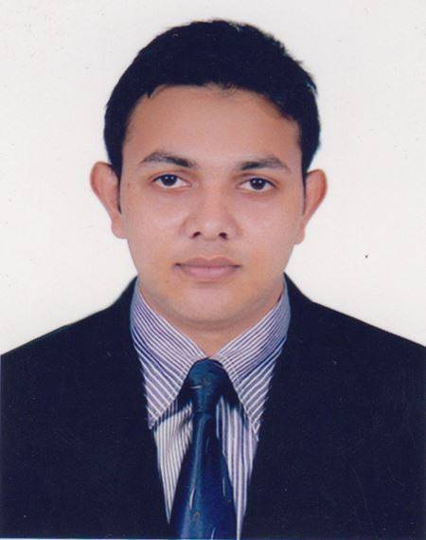
Career Objective

To be a dynamic executive in a reputed organization where challenges are the order of the day, to implement new thoughts and ideas and also to be a team leader and win the laurel for the organization.
First Contact (Present)

47/3 South Jatrabari (Nobinagor),
Dhaka-1204
Cell: 01686191820
E-mail: smtahemal@gmail.com
Personal Details

Full Name : S.M. Tanvir Ahmed
Nick Name : Tanvir
Father’s Name : S.M. Monjurul Haque
Mother’s Name : Kazi Lutfunnahar
Permanent Address : Vill &P.O: Hafizpur; Upozilla: Monohardi; District: Narsingdi.
Date of Birth : January 3, 1995
Nationality : Bangladeshi (By Birth)
National ID No : 19956815233000031
Religion : Islam
Sex : Male
Marital Status : Single
Hobby : Travelling
Blood Group : O+

Educatuinal Qualification

MA(Evening) in English Department of English
(Running) Jagannath University

BA (Hons) in English GPA: 2.94 out of 4.00
Year-2018;
Department of English
East West University

H.S.C Examination GPA: 4.10 out of 5:00
(Science) Year-2012; Board-Dhaka
Panchkandi Degree College

S.S.C Examination GPA: 4.75 out of 5:00
(Science) Year-2010; Board-Dhaka
Chalakchar High School

Communication Skills

- Excellent interpersonal communication skill with pleasant personality.
- Well conversant in Bengali and English.
- Able to understand Hindi.

Computer Skills
- Efficient in Operating Systems (Windows 7, Vista, XP)
- Efficient in Microsoft Office 2010, 2007, 2003, and Power Point
- Graphics Software: Picasa, ACD, Adobe Photoshop

Language Proficiency
- English: Excellent in four basic skills of the language, that is, reading, writing, listening and speaking.

Key Competencies

- Proactive, ambitious, creative, energetic and willing to work under pressure.
- Highly motivated, result oriented and dynamic.
- Well-organized and a good team player.
- Able to take responsibility and to manage independently.
- Able to plan and organize assignments according to priority.
- High level of passion & integrity in business behavior.

Extra Curricular Activities

- General Secretary, Student for Society (Social Organization).
- Member, Jagannath University Debating Society(JnUDS)
- Former Member, East West University English Conversation Club(EWUECC)
- Former Member, Rotaract Club of East West University (RACEWU)
- Former Member, East West University Sports Club(EWUSC)
- Former Member, East West University Debating Club (EWUDC)
- Former Football player, Department of English, East West University.

Training Workshops/ Seminars/ Assemblies/ Conferences

Successfully participated in a good number of training workshops, seminars, assemblies & conferences on career management, publicly important social issues & leadership building workshops/seminars/conferences.

Special Interest

Thinking, Reading, Travelling, playing, Gossiping & Internet Browsing.

Aim in Life

To explore myself in the highest potential & be an ideal one.

Achievements

- Participated ISSB for 73 BMA(Bangladesh Military Academy) Long course (Army)
- Runners-up Trophy for Department of English, EWU at Intra-Department Football Fest, 2016.
- Achieved many medals & award for playing at local level.

Service

Nil

References

Dr. Farzana Akter
Associate Professor& Chairperson
Department of English
East West University
A/2, Jahurul Islam Avenue, Jahurul Islam City, Aftabnagar, Dhaka-1212
E-Mail: farzana@ewubd.edu

Dr. Moriam Quadir
Associate Professor & Ex-Chairperson
Department of English
East West University
A/2, Jahurul Islam Avenue, Jahurul Islam City, Aftabnagar, Dhaka-1212
Cell: 01726411937
E-mail: moriam@ewubd.edu

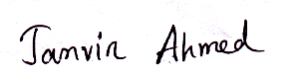

Signature
Date: 01.04.19

