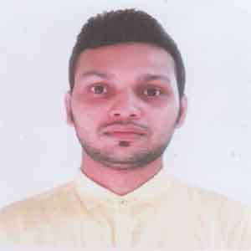
Resume of
Tanvir Ahamed

5(C), House# 06, Road# 04, Block# E
Banosree, Rampura, Dhaka-1219.
Mobile: 01926723200/ 01814857079
E-mail: tanvirbba14@gmail.com

1 Career Objective:

I want to be part of the success in an environment of growth and excellence with dedication, sincerity, enthusiasm& loyalty.

2Educational Qualifications:

2.1 Bachelor of Business Administration (BBA):

Institution | : | Northern University Bangladesh
Major | : | Accounting
Year of passing | : | 2018
Duration | : | 4 years
CGPA | : | 3.20 out of 4
Internship | : | Gulshan 2,Branch, Al-Arafa Islami BankLimited

2.2 Higher Secondary Certificate (HSC):

Institution | : | Austagram Rotary Degree College
Group | : | Business Studies
Year of Passing | : | 2012
Result | : | 3.90out of 5
Board | : | Dhaka
2.3 Secondary School Certificate (SSC):

Institution | : | AustagramPilot High School
Group | : | Business Studies
Year of Passing | : | 2010
Result | : | 3.69 out of 5
Board | : | Dhaka
3Personal Details:
Name | : | Tanvir Ahamed
Father’s Name | : | Late, Misbah Uddin
Mother’s Name | : | Jusna Akrar
Present Address  Permanent Address | :  : | 5(C), House#06, Road#04,Block#E,Banosree,Rampura,  Dhaka- 1219.  Village: Austagram, PO: Austagram,PS: Austagram, Dist: Kishorganj.
Date of Birth | : | 9/11/1995
Marital Status | : | Single
Sex | : | Male
Religion | : | Islam
Nationality | : | Bangladeshi (by born)
4 Special Qualifications&Language Proficiency:

5.1 Good interpersonal Skill.
5.2 Ability to work with the team.
5.3 Ability to work under pressure.
5.4 Pleasant personality.
5.5 Good Command over English & Bengali

5Interests & Extracurricular activities:

- Quiz Competition, Case study competition, Business, Computing, Cycling, Biking.
- Member of skill development club, social welfare club & sports club. Environment Club

6Computers Proficiency:

6.1Tally &Website Management, Internet browsing proficiency, MS Word, Excel, Power Point.

7References:

Reference 01Reference 02
Name: Md. Shoriful Islam Name: Md. Towhidul Islam
Assistant Professor of Finance & Coordinator DIG Prison, Dhaka Division.
Department of Business Administration Mobile:- 01712129019 Northern University Bangladesh
Mobile:- +88 01755-514692
E-mail:-shorifnub08@gmail.com

8Signature:

……………………………

