Curriculum Vitae
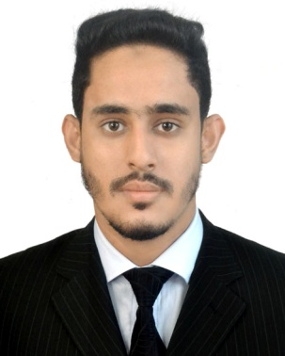
Tanvirol Islam
Contact & Address
Cell No: 01715711996
E-mail: tanvir374@gmail.com
Address: House no: 07, Road no: 03 (A), Block- A,
Shahporan Uposhohor, Khadim Nagar , Sylhet.

Career Objective:
To use my enthusiasm, academic skills, ability to communicate ideas, commitment to accept a challenging working in order to perform quality work and build up professional career with high ethical standard.
Educational Qualifications:
Bachelor of business administration (BBA)
Institution : Madan Mohan College
Subject Name : Accounting
Grade : (CGPA: 3.10 out of 4)
Session : 2014-2015
Passing Year : 2018
University: National University

Higher Secondary Certificate (H.S.C)
Institution : Sylhet Govt. College
Group : Business Studies
Grade : (GPA: 4.40 out of 5)
Session : 2012-2013
Passing Year : 2014.
Board : Sylhet.

Secondary School Certificate (S.S.C)
Institution : Hazrat Shahparan (R:) High School, Sylhet
Group : Business Studies
Grade : (GPA: 4.38 out of 5)
Session : 2010-2011
Passing Year : 2012.
Board : Sylhet.
Professional Skills
- Ms. Office (MS Word, MS Excel, MS Power Point & Internet Browsing)
- Have strong analytical & problem solving skills.
- Able to perform any dynamic job independently, capable to maintain records accordingly.
- Well mannered, smart, structured disciplined & punctual.

Language proficiency:
- Bengali: Native language
- English: Very good command in English both in written and verbal form.

Personal Information:

- Full Name : Tanvirol Islam
- Father’s name : Md. Abdul Basit
- Mother’s name : Monowara Begum
- Permanent address: Vill: Shahporan Uposhohor , Post: Khadim Nagar,
Upozilla: Sylhet Sadar, Dist: Sylhet.
- Present address : Vill: Shahporan Uposhohor, Post: Khadim Nagar,
Upozilla: Sylhet Sadar, Dist: Sylhet.
- Date of birth : 05 August, 1996
- Sex : Male.
- Marital Status : Single.
- Height : 5.8 Inc.
- National ID No : 5958184284
- Religion : Islam
- Nationality : Bangladeshi (By Birth).
- Blood Group : B+ (Positive).
- Cell No : 01715711996

References
Hussen Ahmed Ambia
Assistant Professor,
Lecturer in English
Jaintapur Tayob Ali Degree College, Sylhet.
Cell- 01711- 912565

Certification
I, certify that to the best of my knowledge and belief, this CV correctly describes me, my qualifications, and my experiences.

Date :............................. Signature :..............................

