Curriculum Vitae 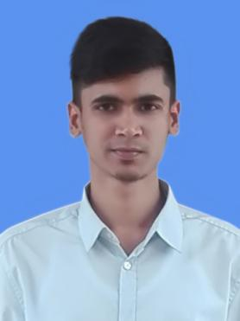

Of

Tanzim Ahmed Rifat

C/O: MD Abdus Sattar Mondol

Address: p.o:Sirajgonj Dist:Sirajgonj

Mobile: 01681256797
Email:ahmedtanzim30@gmail.com

Career Objective:

To work in a progressive organization that incorporates varied spectrums of work & diversity, this endows consistency, competency & expertise in professional as well as social spheres, enabling collective excellence and technical growth, personal fulfillment with welcome attitude for new ideas and concepts to enhance the overall growth of the organization. To build a fascinating career in challenging business environment with dynamism, confidence and honesty, I would like to devote all my knowledge, Skills, and experience to any professions.

Key Competencies:

- Versatile to lead from the front, overall a hardcore performer.
- Innovative, Organized and Dedicated.
- CAN-DO attitude with adaptability and consistency.
- Honest and Faithful, Dedicated and Punctual, Disciplined and Systematic.
- Superior analytical and strategic skills.
- Capable of working in any environment.
- Enthusiastic in challenging work place and learning new things. and
- communicating and organizing skills.

Educational Information:
Degree | Institution | Board/University | GPA | Year
MSS  (Public Administration) | Jahangirnagar University | Dhaka | 3.30 | 2019
BSS  (Public Administration) | Jahangirnagar University | Dhaka | 2.88 | 2017
HSC (Business Studies) | BAF Shaheen School & College Dhaka | Dhaka | 4.40  (Scale of 5) | 2013
SSC (Science) | BAF Shaheen School & College Dhaka | Dhaka | 5.00  (Scale of 5) | 2011
Language Proficiency:
Bengali : Mother tongue.
English : Both in speaking and writing.
Computer Skill:
Office Management : MS Word, , Internet (E-mail, Browsing) etc. Operating System : Microsoft Windows 2003, 2007, 2010 and XP.

Personal Information

- Full Name : Tanzim Ahmed Rifat
- Father’s Name : MD Abdus Sattar Mondol
- Mother’s Name : Mst.Nasima Khatun
- Place of Birth : Bangladesh
- Date of Birth : 9 june 1996
- Blood Group : O positive (O+)
- Gender : Male
- Religion : Islam
- Marital Status : Single
- Nationality/Citizenship : Bangladeshi
- Current Address : Room-329,Bangabandhu Sheikh Mujibur Rahman Hall,JU
- Permanent Address : Post Office: Sirajgonj
Thana: Sirajgonj
District: Sirajgonj
- Mobile No : 01681256797
- Email : ahmedtanzim30@gmail.com
- Personality:
- • Hobby : Playing Football(Inter Shaheen Football Champion,Present Captain
of Department of Public Administration,Jahangirnagar University),
Listening Music
- • Personal Strength : Hard-worker, Creative and Innovative, Honest.
Declaration:

“I do hereby declare and certify that all information stated above in this profile is true and complete to the best of my knowledge.”

………20/08/2019…………….
( Tanzim Ahmed Rifat)

