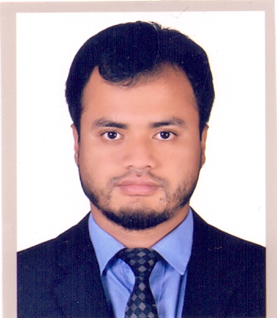
Curriculum Vitae
of
Mohammed Tarakol Islam
Present Address:,
C/O. Mohammed Morom Ali
Vill: Pekpara, P.O: Bangla Bazar
P.S: Dowara Bazar, Dist : Sunamganj
Mobile Number: 01750-448113
E-mail: tarekulislam1992@gmail.com

Career Objective:

I would like to build a career in challenging and professional workplace and achieve the higher level of professionalism. I love to apply my creative, technical and interpersonal skills to enhance the organization’s image and to be part of a successful team.

Academic Qualification:

- Bachelor of Laws 4-year LLB, Honor’s. (LLB)
Name of Institute : Sylhet International University.
University : Privet University
Subject : LL.B (Hon's)
Result : 2.67 (out of 4)
Year Duration : 4 year
Year of Passing : 2017

- Higher Secondary School Certificate (Alim),
Name of Institute : Shah Jalal Jameya Islamia Fadil Madrasah, Sylhet
Group : General.
Board : Madrasha
Year of Passing : 2010
Result : G.P.A – 3.83 (out of 5.00)

- Secondary School Certificate (Dakhil)
Group : General
Institute : Islampur Sidqea Dakhil Madrasah, Sunamganj
Board : Madrasha
Year of Passing : 2008
Result : G.P.A-3.81 (out of 5.00)

Language Skills:
- Good at Speaking and writing in both Bengali and English.

Computer Skill:

- Ms Word, Ms Excel, Ms Power Point, Ms Excess & Internet Browsing.

Job Objective:
I want to take challenge of job hazard. I would like to welcome the change to work as a part of dynamic working team where I believed that I could make a significant contribution while developing skills yet future.

Personal Information:
Name : Mohammed Tarakol Islam
Father’s Name : Mohammed Morom Ali
Mother’s Name : Hosna Akther
Permanent Address : Vill: Pekpara, P.O: Bangla Bazar
P.S: Dowara Bazar, Dist : Sunamganj
Mailing Address : Vill: Pekpara, P.O: Bangla Bazar
P.S: Dowara Bazar, Dist : Sunamganj
Date of Birth : 07/05/1992
Marital Status : Unmarried.
Religion : Islam.
Gender : Male.
High : 5’4’’
Nationality : Bangladeshi (By Birth)
Blood Group : AB+

ACHIEVEMENT AND INTEREST

- Traveling, listening music, plying, reading novels etc.

DECLARATION: I certify that all information I submit in this Resume and in Support of this Resume is true, correct and complete to the best of my knowledge.

Signature

- Tarek
…………….......................
Mohammed Tarakol Islam
Date: 25.07.2019

