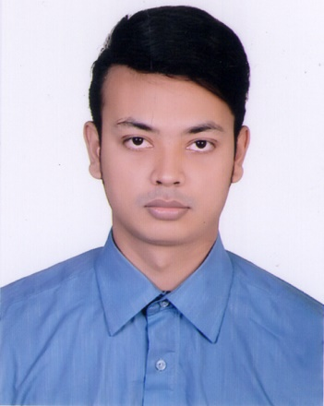
Curriculum Vitae
Tarek Mahmud Ahkanda
House: 202/2, East Kazipara
Kafrul, Mirpur, Dhaka-1216.
Cell: 01775163930

Career Objective:
To work with a company where I will utilize my education, Skills and experience in a consistently positive atmosphere. I will learn and implement new technologies for the betterment of the company as well as my personal development.

Academic Qualification:

Examination | Institution | Subject/Group | Passing Year | University/ Board | CGPA/  GPA
B. B. A Honors | Mirpur University College | Marketing | 4Year Running | National | Appeared
H.S.C | Mirpur University College | Business Studies | 2013 | Dhaka | 3.10
S.S.C | Adarsha High School | Business Studies | 2011 | Dhaka | 3.50

Personal Profile:
Father’s Name | : | Noor- Muhammed Ahkanda
Mother’s Name | : | Luthfun Naher Ahkanda
Date of Birth | : | 6th September, 1995
Blood Group | : | B+
Religion | : | Islam
Marital Status | : | Unmarried

Skill & Ability
Computer Skills | Office Management  User of MS Word, Web Developer internet relate software
Language Skill | Listening, Reading, Writing and Speaking (Bangla & English)
Personal Skills | - Organizing, coordinating and monitoring ability.  - Self-motivated and quick learner, honest.  - Hard working and able to work under pressure.

Extracurricular Activates:
Work for ‘‘Blood Donation Bangladesh’’ as a volunteer.
Attending and Organized the cultural program held at NIFT. Played Badminton.

Other’s Experience:
I also worked many fashion showroom like EASY, Smart Tex fashion wears ltd. (Package job).
Also worked Dhaka International Trade fair and many Event Company

_________
Signature
Date: ________________

