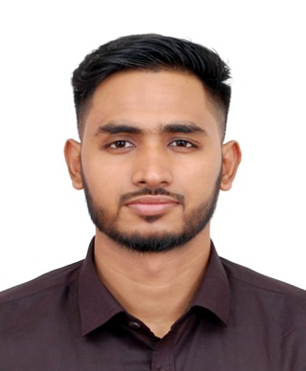
Tareq Khan
Contact No: +8801719739191
E-mail: tareq6600@gmail.com

Educational Qualification

Bachelor of Business Studies
- University : National University
- Passing Year : 2017
- CGPA : 3rd Division

Higher Secondary School Certificate
- Board : Sylhet
- College : Madan Mohan College, Sylhet
- Passing Year : 2012
- GPA : 3.60 (scale of 5.00)
- Group : Business Studies

Secondary School Certificate
- Board : Sylhet
- School : Shahjalal Jamia Islamia School and College, Sylhet
- Passing Year : 2010
- GPA : 3.13 (scale of 5.00)
- Group : Humanities

Knowledge and Skills

- Self-motivation, Initiative with a high level of energy.
- Verbal communication skills.
- Decision making, Critical thinking, Organizing and planning.
- Patience and Tolerant.
- Quick Learner.
- Flexible to different situations and friendly.

Skills: Microsoft word, Excel, PowerPoint, Amazon SEO, Blog Posting, SMM

Professional Experience

- Managing Executive (1st Jan 2016 – 30th Apr 2016)
Star Travels
Company Location: Sylhet

- Visa Advisor (1st Jan 2016 – 31st Dec 2016)
Air Shahporan Intl.
Company Location: Sylhet

- Visa Advisor (1st May 2012 – 31st Dec 2015)
Air Shahporan Intl.
Company Location: Sylhet

- eCommerce Advisor (1st May 2017 – Cont.)
Sylcon Enterprise
Company Location: Sylhet

Language Proficiency

- Mother Language : Bengali (native)
- Foreign Language : Have good command in English speaking and writing.

Personal Details

Father’s Name : Nurul Islam Khan
Mother’s Name : Ayesha Islam
Permanent Address : House-107, Block-C, East Dhupadigirar par, Sylhet.
Date of Birth : 12.05.1992
Religion : Islam
Nationality : Bangladeshi by birth
Marital Status : Single

References

1. Imran Latif 2. Sayed Ahmed Khan
CEO Double Glazing
Macquarie Society Baghbari, Sylhet
Immigration Advisory, Sylhet Cell No: +8801715-456344
Cell No: +8801675-014052 Email: sayed3100@gmail.com
Email- macuarie.society@gmail.com

Declaration

I understand that withholding pertinent information or giving false information in the Curriculum Vitae will make me ineligible for the post or will make me liable to the dismissal. Bearing this in mind, I certify that the above statements and information are correct and complete.

Signature
---------------------------------------
(Tareq Khan)

