MOHAMMED RAFIQUE ULLAH  In Care of : Samsul Hoque Master Bari  Village : North Lamchy  Post Office : Abdullah Miarhat  Thana : Kabirhat  District : Noakhali.  Mobile : 01859686868  E-Mail : rafiquerobisheba@gmail.com |  | 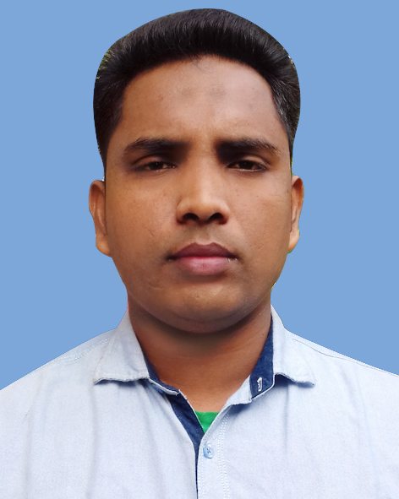
Date of Birth | 1st January , 1992
Education | M.B.S  Noakhali Govt. College Noakhali  Passing Year: 2015  Group : Management  Status: 2.53  National University  Bachelor Degree  Kabirhat Govt. College, Noakhali  Passing Year: 2012  Group : B.B.S  Status: 2nd Division  National University  Higher Secondary Certificate  Kabirhat Govt. College, Noakhali  Passing Year : 2009  Group : Business  Status: 2.30 Scale of ( 5.00 )  Comilla Board  Secondary School Certificate  Abdullah Miarhat Dakhil Madrasha  Group : General  Result : 3.92 Scale of ( 5.00 )  Madrsaha Education Board (Dhaka)
Self Assessments | - Optimistic confident and friendly as a person.  - Sincere, hard working and dutiful.  - Able to set priorities and routine tusks  - Ability to convince the different type of customers.
Language | Reading/writing/speaking in Bengali, English.
Computer Literacy | Microsoft Office Adobe Photoshop  Internet Explore Operating System
Experience | Duration : 06 Years  Designation : Robi Sheba Executive  Company Name : Wahid Media & Computers  Company Address : Mahbub Shopping Center, Kabirhat, Noakhali.
Personal Details | Name : Mohammed Rafique Ullah  Father’s Name : Md.Abdul Julil  Mother’s Name : Amena Khatun  Permanent Address : Samsul Hoque Master Miar Bari  Village: North Lamchy  Post Office: Abdullah Miarhat  Police Station: Kabirhat  District: Noakhali.  Postal Code: 3800  Nationality : Bangladeshi  Religion : Islam  Height : 5'-7''  Sex : Male  Blood Group : “O⁺” Positive
"I CERTIFY THAT ALL INFORMATION ST ATED IN THIS RESUME IS TRUE AND COMPLETE TO THE BEST OF MY KNOWLEDGE. I AUTHORIZE THE CONCERNED AUTHORITY TO VERIFY THE INFORMATION PROVIDED IN THIS RESUME. "
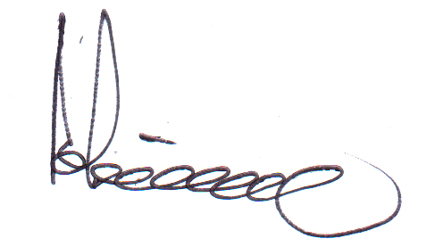
-------------------------------------------
(Mohammed Rafique Ullah)

