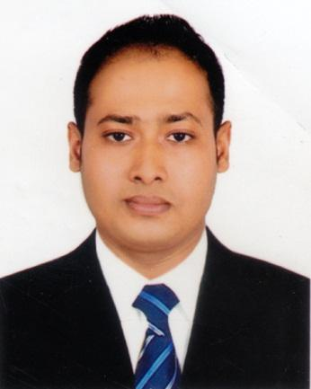
Md. Mahfuz Hasan House # 06, Road # 02, Block # B
Banasree, Rampura, Dhaka-1212
Cell No.: +8801814776254, 01725023678
E-mail: mh.dinar54@gmail.com

Career Objectives

To serve such an organization where I can devote myself effort to achieve the goal of the company. Would take the job with a great sense of responsibility. Enjoy the challenge of new situation and expect to make positive contribution of the position.

Educational Qualification

Diploma in hotel management
Subject: Food and Beverage Service
Institute: Unique Professional Development Academy for Training and Education(UPDATE)
Result. Pass
Bachelor of Business Administration (BBA) in HRM
CGPA : 2.70out of 4
Passing year : 2019
Institute : Stamford University of Bangladesh

Higher Secondary Certificate (H.S.C) in Science
GPA : 3.40
Passing year : 2012
Institute : Ishurdi Govt College, Ishurdi,Pabna

Secondary School Certificate (S.S.C) in Science
GPA : 4.13
Passing year : 2009
Institute : Dashuria M.M High School Pabna

Experiences

I worked 7 month as a intern in westin dhaka hotel in customer service dept.

I worked Westin Dhaka Hotel since 14th May 2014 to 15th November 2016 as a Food and beverage guest service Associate.

I worked at the Marriott international (le Meridien Dhaka) Hotel From 13th May 2017 to 31 may 2020 as a Food and beverage guest service Associate.

Language Skill

Bengali: Native language as well as excellent in reading, writing, and speaking.
English: Reading, writing and speaking
Hindi : Speaking

Personal Profile

Father Name : Let.Abdul Khaleque
Mother Name:Mst.Shahina Yasmin
Date of Birth : 4th May 1993
Religion : Islam (Sunni)
Nationality :Bangladeshi(by Birth)
Height : 5.7
Permanent address : dashuria,ishurdi,pabna

Co-corium activities

Traveling, Browsing
Experience in welfare activities.

Strengths

Self-Motivate, Sincere, Hard Working and Comfortable working along or as part of a team.

References.

Mr.Hedayetul islam
Restraurent Manager of le Meridien Dhaka hotel
Mob:01790060898

Mr. Shafique
Shift Asst.Manager
The Westine Dhaka
Main Gulshan Avenue, Gulshan 2
33 Gulshan Avenue,
Dhaka 1212
Cell: 01731221133

Experience certificate From westin dhaka hotel
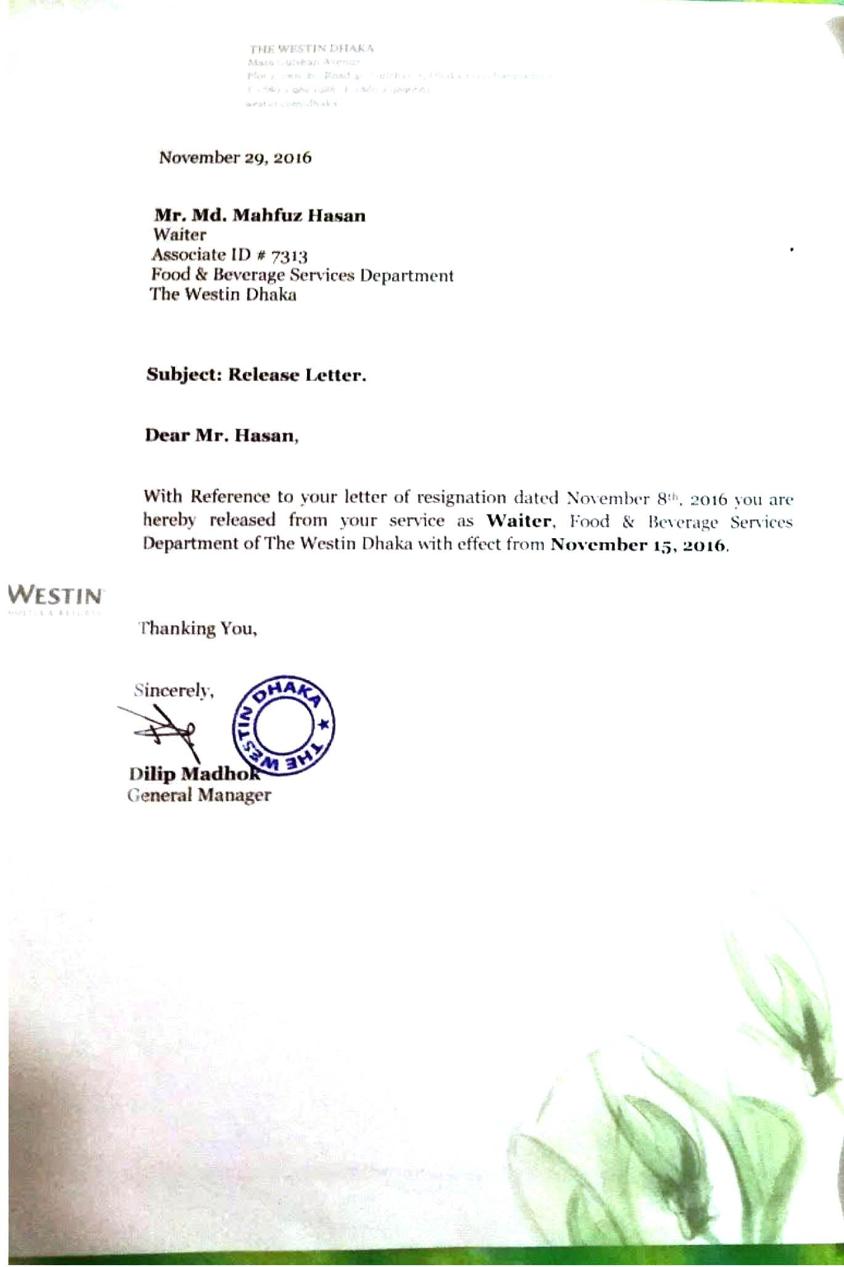
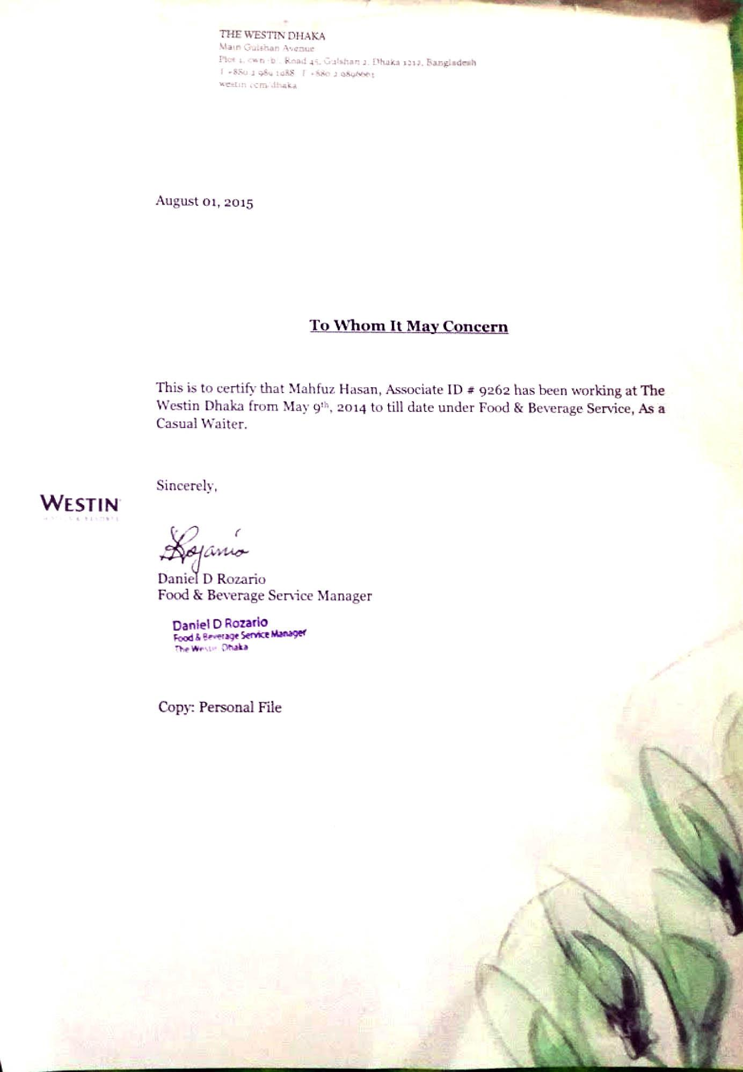

Diploma Certificate.

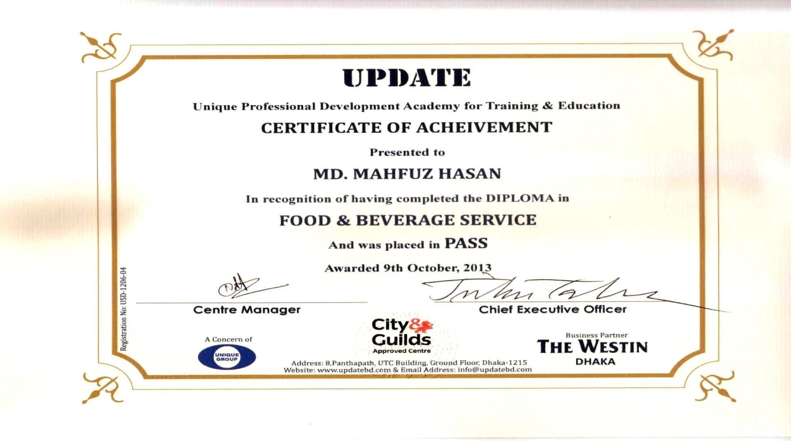

Internship Certificate from Westin Dhaka hotel.
