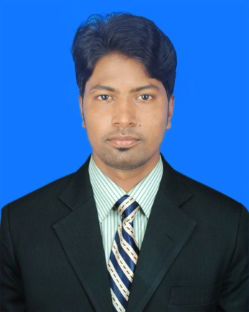
CURRICULUM VITAE

MD WALIULLAH
Vill: Boishkhali, P.O: Sailkhali,
P.S: Shyamnagar, Dist: Satkhira.
Mobile: +8801933-189813
Email: mdwaliullahbabu@gmail.com

Career Objective:

To be a dynamic member of any leading organization where I can add value to it and I can develop my career. To work in a challenging and competitive environment where I can fulfill my job responsibilities efficiently and effectively through my sound analytical knowledge, strong leadership and interpersonal communication skills.

Academic Qualification:

Diploma in Engineering(Computer)
- Institution : Khulna Polytechnic Institute, Khulna.
- Subject : Computer
- Duration : 4 Year
- Result : GPA 3.47 (out of scale 4)
- Session : 2014-15
- Passing Year : 2018

Secondary School Certificate(Science )
- Institution : Kaikhali S.R High School
- Group : Science
- Result : GPA 4.50 (out of scale 5)
- Passing Year : 2014

Internship Company
- Institution : Computer.Edu, Khulna.
- Subject : Web Design
- Passing Year : 2018(Jan-Apr)
- Result : A+

Computer Proficiency
: Office Program: MS Word, MS Excel, MS Access
: E-mail, Internet Browsing, and Social Networking.
: Basic knowledge of computer hardware & software.
Language Proficiency:

- Bengali: Have good command in reading, writing, listening & speaking.
- English: Have good command in reading, writing, listening & speaking.

Personal Information:

- Full Name : Md Waliullah
- Father's Name : Md Shahadat
- Mother's Name : Nurunnesa Begum
- Present Address : Vill: Deyana, P.O: Daulatpur, P.S: Daulatpur,
Dist: Khulna.
- Permanent Address : Vill: Boishkhali, P.O: Sailkhali, P.S: Shyamnagar,
Dist: Satkhira.
- Home District : Satkhira
- Sex : Male
- Date of Birth : 10-04-1998.
- Blood Group : O+
- Height : 5Feet 7.5 Inches
- Weight : 61 Kg.
- Religious Belief : Islam.
- Marital Status : Unmarried.
- Nationality : Bangladeshi (by birth)
- Birth Reg. No : 19988718647002805
- Hobbies : Internet Browsing
References:

1. Md Abdul Hakim 2. Md Shahajan Siraj
M,A in English Vill: Boishkhali, P.O: Sailkhali,
Govt. B.L University College P.S: Shyamnagar, Dist: Satkhira
Mobile No: 01924-390296 Mobile No: 01964-161139

Declaration::

I hereby declare that the above given information are true and to the best of my knowledge.

Date: ...../......./......... ………………………………
(Md Waliullah)

