Curriculum Vitae

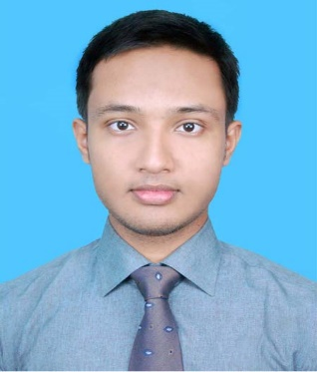
Name: Saifullah Khaled

Mailing Address:

Elias Lodge, Haji Chand Miah R/A,
Chandgaon, Chattagram.

sakhaled92@gmail.com
Contact Number : +880 1878-861996

Career Objectives

To serve in such an organization where I can devote my full effort to achieve the goal of the company. Would take the job with a great sense of responsibility, enjoy the challenge of new situation and expect to make a positive contribution in position.

Academic Records

- B.Sc. in Civil Engineering
CGPA: 3.28
Southern University Bangladesh
O.R Nezam Road, Chittagong
Year: 2019

- Higher Secondary School Certificate ( Alim )

Main Field of Study : Science
Result : GPA 3.83 out of 5.00
School : Darul Ulum Kamil Madrasah, Chittagong.
Board : Madrasah.
Year : 2013

- Secondary School Certificate ( Dhakil )

Main Field of Study : Science
Result : GPA 4.44 out of 5.00
School : Darul Ulum Kamil Madrasah, Chittagong.
Board : Madrasah.
Year : 2010

Job Experiences:
Company Name: Bank Asia
Post: Customer Service Officer (CSO)
Duration: 01-12-2020 to 19-04-2021

Computer Knowledge

- Microsoft Office Application Program,
- Internet Browsing, Email Communication,
- Auto CAD (2D, 3D), ETABS,
- Adobe Photoshop, Illustrator,
- Audio, Video Editing etc.

Skills
- Outstanding Interpersonal Skills
- Team Player
- Detailed-Oriented
- Can Handle Many Assignments – Multi-Tasking
- Strong Networking Skills

Language Proficiency
Language | Reading | Writing | Speaking
English | High | High | Medium
Bangla | High | High | High
Hindi | - | - | Medium

Personal Details

- Name : Saifullah Khaled
- Father’s Name : Rashid Ahmed
- Mother’s Name : Fatema Begum
- Present Address : Elias lodge, Haji Chand Miah R/A, Chandgaon, Chattagram.

- Permanent Address : Vill- West Mirzapur, P.O- Mirzapur,
P.S- Hathajari, Dist. - Chittagong.
- Date of Birth : 30th September, 1992.
- Nationality : Bangladeshi
- National ID : 1006305104
- Religion : Islam
- Gender : Male
- Marital Status : Single
- Interest : Reading Books, Playing Sports, Listening Songs etc.
- Contact No. : +880 1878-861996
- E-mail : sakhaled92@gmail.com

References:
1. Md. Hemayet Hossain
Agent & Managing Director
Bank Asia Agent Banking
Chittagong, Bangladesh
Cell: +880 1820-246233

Declaration

I certify that, the statement made by me herein is complete and true to best of my knowledge and belief.

Yours Faithfully and Sincerely

Saifullah Khaled Date: / / 2021

