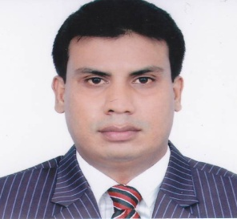
CURRICULAM VITAE
of Uzair Ahmed Chowdhury
Present address : 50A Noboposhpoo,Jawtarpur,Mirabazr,Sylhet,Bangladesh.
Permanent address : Village:Gugarkul(NowaBari),P.o:Ronkeli North,P.S:Golapgonj,
Dist:Sylhet,Bangladesh.
Mobile : +8801632778199, Skype : uzairbd17@gmail.com
Email : uzairbd17@gmail.com.
Career objective : I am an accomplished and driven professional with an entrepreneurial spirit looking for challenging role in an organization where i can make a name for my skill and hard work and be financially rewarded for my performances.
Career Summary :
Designation : Teacher
In 2007-2008 : Worked as an English teacher at Shahjalal Upashahor Academy ,Block:I,
Upashahor ,Sylhet,Bangladesh.
In 2017 : I taught as an English teacher at Captain Academy,Block-B,Upashahor,
Sylhet,Bangladesh.

Duties &
Responsibilities : Teaching students in primary & secondary school,delievering lecture in
classroom both in Bengali & English medium, organize class work, home work for practicing in home, teach students in good behavioral skill.
Educational Qualifications:
Exam Title | Concentration | Institute | Result | Year | Duration | Achievements
S.S.C | Science | Golapgonj Jamia High school | First division | 1998 | 2 years | Secondary school certificate
H.S.C | Science | M.C Academy School&college | Second  Division | 2000 | 2 years | Higher Secondary
B.A(Hons) | English | NationalUniversity  Bangladesh. | Pass | 2006 | 3 years | B.A Pass degree

Language proficiency:
IELTS International English language testing System:
Writing 5.5 | Reading 5.0 | Listening 5.5 | Speaking 6.5 | Overall Bandscore 5.5

Extra curricular activaties:
I like to pass my leisure time by reading books,science ,fiction internet browsing.I am sports loving and play indoor and our door games such as :Pool,Cricket,Football .Riding bike &travelling is my hobby.
Referance : Available on request.

