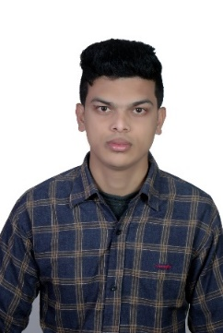
WAHIDUR RAHMAN (Jospeh)
PERMANENT ADDRESS AND

MAILING ADDRESS: BANGLADESH
49 Home Mokhlisa Villa, West Pir mohollah, Amberkhana, SYLHET-3100

E-mail: wrahmanj@googlemail.com | Github.com/WahidurRahman

Career objective: To play a challenging and demanding role in an organization that has development and learning opportunities and make a substantial positive contribution to its success.

Education: Secondary School Certificate

Sylhet Technical Gov. School & College.
Group: Electrical engineering.
G.P.A: 3.62 (On a 5 point scale)
Year of passing: 2013
Board: Technical education board.

Higher Secondary Certificate

Sylhet Technical Gov. School & College.
Group: Electrical engineering.
G.P.A: 3.39 (On a 5 point scale)
Year of passing: 2016
Board: Technical education board.

Bechelor of Science in C.S.E

International University, Sylhet
Department: C.S.E (Hons)
DROPOUT

Personal Qualities: | - Excellent communication and presentation skill  - Strong analytical and conceptual skill  - Ability to work in a team  - Creative approaches and enthusiasm to reach the goal  - Self-starter, flexible, stress-resistant

Computer Knowledge: Web Design, WordPress, Internet Marketing,
HTML, CSS, JavaScript, Object-Oriented Programming, Node.js,
Computer Hardware Skills, Photoshop, Illustrator, InDesign.
Language Proficiency : English, Bangla.
Personal Details: Name: Wahidur Rahman (Joseph)
Fathet’s Name: Md. Julhash Miah Pir
Mother’s Name: Ms. Rafiqun Nesa
Date of Birth: 06-012-1995
Home District: SYLHET - 3100
Blood group: O+
Nationality: Bangladeshi
Religion: Human
Marital Status: Single
Phone(Cell): +8801717006937
Permanent Address &
Mailing Address: 49 Okkotan, Mokhlisa villa, West pir mohollah, Amberkhana, Sylhet-3100, Bangladesh

I solemnly declare that all the information mentioned above is true.

Signature:
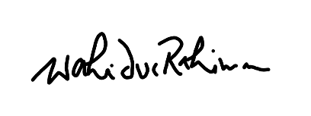
Wahidur Rahman
Date: 19-09-2018

