SHARMIN AKTER NISHA
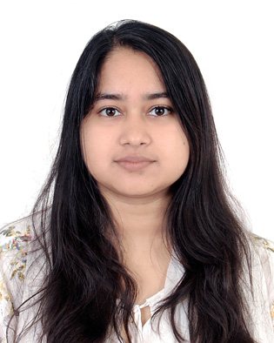 | Ashugonj-3402, Brahmanbaria  Phone: 01682722792  Email: nihadsharmin69710@gmail.com

Objective
I am a fresh graduate wanted to work on an entry-level position to begin my career in a high-level professional environment.

.Education
B.A (Honors) in Bangla from Shahjalal University Science & Technology, Sylhet
Duration : 2014-18
The syllabus focuses on Bengali literature, History of Bengali literature, World literature, Bangla Language: Applied rules, Phonetic and Bangla Phonology, Social & Cultural History of Bangladesh, Poetics & Aesthetics. It also includes non-major courses, such as CSE, Economics, English literature, Sociology, Social work, Linguistics anthropology, Political science, Public administration.
- Cumulative CGPA 3.30 (out of 4)
H.S.C (commerce) 2013
- GPA-5.00 (out of 5)
S.S.C (commerce) 2011
- GPA-4.81 (out of 5)

experience
- Paralegal Training for Advocacy and Legal Advice Center (ALAC) Initiative, organized by (TIB) 22-24 April 2018.
- Field work at Upazila Health Complex organized by (TIB) 2018.
- Ex Yes member of Transparency International Bangladesh(2015-2018)
- Volunteer of National Riverine Olympiad, organized by Samakal and Riverine people 2017.
- Ex member of Speakers Club, SUST (2015-2016)

Skills & Abilities
- Bangla & English language
- Microsoft office suite ( word, excel, power-point)
- Seminar paper writing
- Player (hand ball)

Communication

SEMINAR PRESENTATION ON
- Online Literature.
- Existential Philosophy of the Poetry of Jibonandha Das.
- Subaltern people in the novel of Selina Hossain (Puka-Makorer Ghorboshoti)
- Evaluation of Bengali Hindu name

INTERESTS
- Watching movie
- Reading book

References

Dr. FARZANA SIDDIKA
Professor
Dept. of Bangla
Shahjalal University of Science & Technology
Email- farzanasiddika@yahoo.com

MR. SARKAR SHOHEL RANA
Assistant Professor
Dept. of Bangla
Shahjalal University of Science & Technology
Email- sarkerrandu@gmail.com

