A.K.M.ZIAUL ISLAM CHOWDHURY
  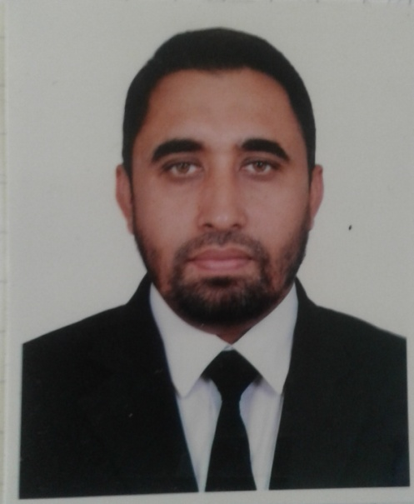
Address: Hs-505, Rd-16/A, Block-F,5TH FLOOR, Bashundara R/A, Dhaka
Mobile : 01817-584388
e-mail : zislam123@gmail.com

Career Objective:
To be complete professional in the Garments Trade

Career Summary:
Started Carrere as a Trainee Team Leader Young One CEPZ.
Senior Office -QA @ Hoplun ltd. DEPZ.

Special Qualification:

Experience in QA, Merchandising,Production follow up.
Having product knowledge of Knit, Woven, Lingerie item, Sportswear products.
Performing inspection through EQC (Online) by downloading file from portal.
Email communication.

Overseas Visit: Visited HongKong Two times to attend buyer Meeting.

Training :- Special training on Negotiation Skill & Tactics (Trained by German professional).

Employment History:
Total Year of Experience : 18 Year(s)

1.Zahra Corporation
(A 100% export oriented Buying house)

Team Leader (Merchandising & Production)
(June’17 to September’18)
Duties/Responsibilities:

Product- Knit, Pullover

Followup production.
Making production plan with factory.
To develop sample.
Price negotiation with supplier and buyer
Correspondence with buyer.
Shipment followup.

 | 2.Sr. Merchandiser (April’12-April’2017)
Metro Group Buying Hk ltd(MGB)
( A German liason office)
Company Location : Uday Tower, Gulshan-1, Dhaka, Bangladesh

Duties/Responsibilities:

Product- Knit, Woven, Pullover & Jackets.
Organize & attend buyer meeting.
To develop sample.
Price negotiation with supplier and buyer
Correspondence with buyer.
Input data in IMS system
Follow up production
Arrange buyer meeting
Shipment follow up
Prepare eqc file.
Arrange and represent buyer meeting.
Responsible for Men’s, Kids, Ladies. Knit T-shirt, Sweater, Bottom.
Production, shipment and Inspection and shipment follow up.

Customer:- Galleria Lafayette (France), Kaufhof, Metro Cash & Carry & ADLER (Germany).

3. | Sr.QA (April’04-March’12)
Metro Group Buying Hk ltd(MGB)
Company Location : Dhaka
Department: QA
Duties/Responsibilities:
1. Prepare Inspection scheduling.
2. Conduct Final inspection through eqc.
3. Conduct in-line inspection if necessary.
4. Attend pre-production meeting to advice suppliers from technical point of view.
5. Submit final inspection report via online.
6. To do factory audit report.
7. Pre production meeting.
8. Production follow-up.
4. | Senior officer –QA & Tecnical ( February 01, 2003 - March 31, 2004)
Hoplun (BD)
Company Location : Dhaka EPZ
Department: Merchandising
Duties/Responsibilities:

Coordinate with sample & Merchandiser to solve the technical comments by Buyer.
To do the final Inspection.To do the in-line inspection.
To check sample from development to shipment.
I was In charge of Finishing, Cutting and sample inspection QA team.
Handle the buyer QCs during final Inspection.
5. | Team Leader (QA) ( February 01, 2000 - January 17, 2002)
Young One Group
Company Location : Chittagong EPZ
Department: Quality Control
Duties/Responsibilities:
I was In charge of 2production floor each floor contain with 8 lines, each lines has 35 Machines.
To do the in-line inspection and Final Inspection of "The North Face" and "Polo Ralph Laurent"
To do the monthly inspection report.

Academic Qualification:
Exam Title | Concentration/Major | Institute | Result | Pas.Year | Duration
M COM | Marketing | University of Chittagong | Second Class, Marks :51% | 1994 | 2 years
B Com | Commerce | no | Third Class, Marks :40.5% | 1992 | 2 years
HSC | Science | Satkania Govt College | Second Division, Marks :50% | 1990 | 2 years
SSC | Science | S.S.G.B High school | First Division, Marks :67.3% | 1988 | 5 years

Training Summary:
Training Title | Topic | Institute | Country | Location | Year | Duration
Vendor certified QC | Organize final and in-line inspection | Polo Ralph Laurel | Bangladesh | CEPZ, Young One | 2000 | 2 days

Professional Qualification:
Certification | Institute | Location | From | To
Certificate course on Knit Merchandising | BIFT | Bangladesh | January 01, 2005 | June 01, 2005

Career and Application Information:
Looking For | : | Top Level Job
Available For | : | Full Time
Preferred Job Category | : | Garments/Textile
Preferred District | : | Anywhere in Bangladesh.
Preferred Organization Types | : | Garments (Woven/Apparel/Knitting), Buying House (Garments)

Specialization:
I have experience in both Quality control and Merchandising.
Also have experience in ladies underwear and sports wears, seam sealing products along with regular basic Garments.
Maintain inspection via eqc (qc material through soft copy) file.
Good communication skill in English.

Language Proficiency:
Language | Reading | Writing | Speaking
Bangla | High | High | High
English | High | High | High

Personal Details :
Father's Name | : | Late Shamsul Islam Chy
Mother's Name | : | Mrs.Nurunnahar
Date of Birth | : | January 24, 1972
Gender | : | Male
Marital Status | : | Married
Nationality | : | Bangladeshi
Religion | : | Islam
Permanent Address | : | P.O+Vill- Sadaha, P.S-Satkania, Chittagong. Bangladesh
Current Location | : | Dhaka

Reference (s):
 |  | Reference: 01 | Reference: 02
Name | : | Mr. Aminul Islam | A.K.M.Shaiful Islam
Organization | : | PVH | Bank Asia
Designation | : | Sr. Technician | Sr.Executive Vice President
Address | :
Phone (Off.) | :
Phone (Res.) | :
Mobile | : | 01754593080 | 01713106206
E-Mail | :
Relation | : | Professional | Brother

