Resume
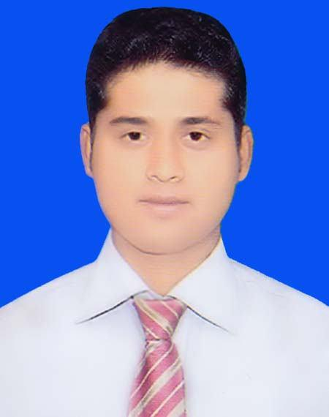

of
MD. SHAKHAWAT HOSSAIN

Mailing Address:

C/O- Md. Abu Bakar Siddik, Vill- Bahadurpur, P.O- Bhawal Mirzapur P.S- Gazipur Sadar, Dist- Gazipur. Cell: 01770-702395
CAREER VISION:

To work in an environment where there is an opportunity of self-assessment & self-improvement in both individual & group based work that will ultimately lead to both organizational and personal growth & also where honesty, commitment, hardworking and performance are the corner stone of career development.

EDUCATIONAL QUALIFICATION:

Masters of Social Science (MSS):

Institution | : | Tongi Govt. College
Subject | : | Economics
Year of Passing | : | 2010
Duration | : | 1 year
Result | : | 2nd Class
University | : | National University
Bachelor of Social Science (BSS):
Institution | : Bhawal Badre Alam Govt. College
Subject | : | Economics
Year of Passing | : | 2009
Duration | : | 4 years
Result | : | 2nd Class
University | : | National University
Higher Secondary Certificate (H.S.C)
Institution | : | Rover Palli Degree College
Group | : | Humanities
Year of Passing | : | 2005
Result | : GPA 3.80 out of 5.00
Board | : | Dhaka
Secondary School Certificate (S.S.C)
Institution | : Rover Palli High School
Group | : | Science
Year of Passing | : | 2002
Result | : GPA 2.75 out of 5.00
Board | : | Dhaka

LANGUAGE PROFICIENCY:

- Mother Language : Bengali
➢ Foreign Language : English (Speaking, Reading and Writing).

PERSONAL SKILL:

- Hard working, attentive & Multi- Tasking ability.

- Able to handle multiple responsibilities.

- Able to improve personal performances.

- Analytical and problem solving skills.

- Listen to people who know better and can learn first.

- Able to build up good relationship.

- Willing to accept challenging responsibilities to fulfill target.

COMPUTER LITERACY:

- Microsoft Office Management & Internet Browsing

INTEREST:

- Public Relationship, Traveling, Playing & Reading Books.

PERSONAL DETAILS :

Full Name | : | Md. Shakhawat Hossain
Father’s Name | : | Md. Abu Bakar Siddik
Mother’s Name | : | Nurun Nahar
Date of Birth | : | 10 November 1985
Home District | : | Gazipur
Marital Status | : | Married
Gender | : | Male
Religion | : | Islam
Nationality | : | Bangladeshi by Birth.
NID | : | 3313054678450
Height | : | 5′ 6″
Weight | : | 65kg
Permanent Address: |  | C/O- Abu Bakar Siddik,
 |  | Vill- Bahadurpur, P.O- Vawal Mirjapur,
 |  | P.S- Gazipur Sadar, Dist- Gazipur.

Announcement:

I do here by declare that the particulars provided here are true and no misinformation is given.

Signature

(Md. Shakhawat Hossain)

