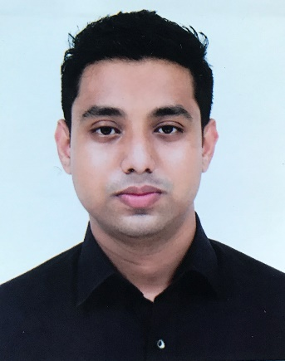
Gulam Rasul Chowdhury
14 Tantipara/Sylhet

Cell: 01682527403
Email: akashchy555@gmail.com
Objective:
Gain adequate knowledge and experience to become successful and skilled developer in software industry. To build a carrier in a challenging environment where I can apply my personal skills and enjoy with helping other.
Summary of Qualification:
Software engineer with strong understanding web design. A quick learner and enthusiastic team player
dedicated to efficiently resolving project issues. Willing to take ownership of core components and
responsibilities.
Education:
LEADING University, Sylhet, Bangladesh
- Bachelor’s in Computer Science and Engineering (CSE) (2015 - 2018) (CGPA 3.66)
Bluebird school & college
- SSC (Science): (GPA 5.0)
Scholarshome school & College
- Science(HSC)(GPA 5.0) (2012-2014)
Technical Skills:
- Java SE, Java EE, Bootstrap, Html, CSS,Laravel,Matlab,javascript, Android studio.
- Git and github.
- Basic knowledge of networking(Cisco)
- Android (Java)
- Coding language : (C), Javascript, Java.
- Language : Bangla ,English, Hindi
- Able to search and find out the problem solution .

Project Experience :
Mobile Based Application (Tutor Finder)
- Android Based application for Tutor service
- Used FireBase database, Authentication & Storage
- Area Based Tutor Search based on the subject requirement

Mobile Based Application (Smart Routine Manager)
- Android Based application for teachers &students (For versity)
- Used FireBase database.for notification.
- Find Teacher’s and students individual routine from analyzing main whole routine.
- Using php for query, from the My Sql data base.

Achievements:
- 6th position in BAS(Bangladesh Academy Of Science) Olympiad(SUST)

Training:
- LUCC freelancing workshop
- LUCC software development workshop
- LUCC web development workshop

Hobbies :
Singing song,playing Football,Gaming (FIFA,DOTA)

References :
Available upon request.

