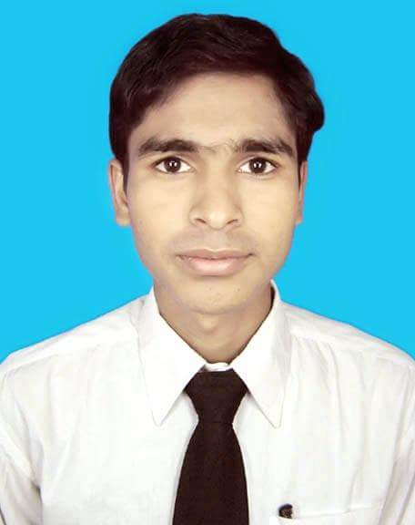
CURRICULUM VITAE
of
Md. Harun or Rashid
Contract No: 01710-390000.
Mail: orrashid69@gmail.com,

Career Objective:

To execute a responsibility where I could use my interpersonal skills, creativity and my learning experiences in order to develop my career and to contribute in the welfare of the Institution.

Professional Experience:

- Name of company : Emkay Enterprises ltd.
Position : Site Engineer
Location : Badda, Dhaka,
Mobil: P.M.:01717135629,
Work Time : 05/11/2018 to till now.

- Name of company : ABM Water Company
Position : Site Engineer
Location : mongla navy camp&Rampal power plant (Site)
Work time : 05 /02/ 2017 to 01/07/2018,

- Name of company :Critical stop.
Position : Site Engineer,
Location : Baddd, Dhaka.
Mobil: P,M:01717136424.
Work Time : 01/01/2016 to 01/01/2017.

- Name of company : Grameenphone.
Position : Customer manager ( STP)
Location : Tamim Enterprises Ltd.(Niamatpur)
Mobile: 01711167086.
Work time :02/03/2013 to 09/09/2014.

Education:

Diploma in Engineering
Institute :National institute of engineering technology, Rajshahi
Passing Year : 2017
Board : Technical Education Board
Group : Civil Technology
CGPA : 2.84 (Out of 4.00)

Higher secondary School Certificate Examination
Institute :Tikrampur technical & business management collage
Passing Year : 2015
Board : Technical Education Board
Group : Accounting
GPA :3.88(Out of 5.00)

Secondary School Certificate Examination
Institute : P.L.B high school .
Passing Year : 2010
Board : Rajshahi
Group : Science
GPA : 2.75 (Out of 5)

Computer Skills:
- Microsoft Office.
- Adobe Photoshop, Adobe Illustrator.
- E-mail & Internet.
- Hardware Maintenance Atc.

Key Qualities:

- Strong desire for leading an honest life with dignity.
- Hardworking, sincere and eager to learn.
- Aspiration to build a career showing superior performance.
- Ability to take responsibility.

Personal Information:

Father’s Name : Md. Abdul Khalek
Mother’s Name : Hafeza Begum
Date of Birth : 06 November, 1993
Nationality : Bangladeshi
Marital Status : Single
Religion : Islam
Sex : Male
Blood Group : O+
Present Address : 777/1, Flat-302, West Kazipara,
Mirpur, Dhaka-1216
Permanent Address : C/O Md. abdul Khalek, Masna, Ramkura,
Niamatpur, Naogaon.

Interests & Activities:

Traveling, Net Surfing, Reading, Photography etc.
Reference :

1. Engr. Md. Aktaruzzaman
Assistant General Manager
Green Dot Ltd./ ABM Water company
Mobile: 01711-991813

Signature:

( Md. Harun or Rashid )

Date:

