AMIT DEBNATH

Mailing Address : Mousumi 16, Mirabazar, Sylhet-3100. 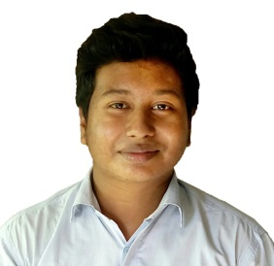
Contact Number : 01761775803, 01515271850
E-mail : amitnathce@gmail.com

CAREER  OBJECTIVE | Seeking responsibilities and opportunities in those areas where academic background and skill can be exercised and field of interests are also synchronized in order to develop and upgrade my career. I am willing committed individual.

ACADEMIC  RECORDS | Degree | University/Board | CGPA/GPA | Passing Year | Department/Group
ACADEMIC  RECORDS | Bachelor of Science (B.Sc.) | Leading University, Sylhet | 3.27 (out of 4) | 2018 | Civil Engineering
ACADEMIC  RECORDS | HSC | Sylhet | 4.00(out of 5) | 2013 | Science
ACADEMIC  RECORDS | SSC | Sylhet | 4.63 (out of 5) | 2011 | Science

TRAINING AND WORKSHOP | Building Code Practices in Practical Fields (May 2018)

EXTRA CO-CURRUCULAR ACTIVITIES | - Theater Executive: Leading University Cultural Club  - Organized several cultural programs in university

LANGUAGE  PROFICIENCY | - Language competency in English & Bengali (Both in speaking and writing).

COMPUTER  LITERACY | - ArcGIS, AutoCAD, ETABS, GRAPHS, SPSS.  - MS Word, MS PowerPoint, MS Excel.  - Programming language(C/C++).

PERSONAL INFORMATION | Name: Amit Debnath  Father’s Name: Ananta Kumar Debnath  Mother’s Name: Suniti Debi  Present Address: Mousumi 16/A, Mirabazar, Sylhet-3100  Permanent Address: Vill: Srinathpur, P.O: Kamalganj (3220),  Dist: Moulvibazar  E-mail: amitnathce@gmail.com  Date of Birth: 22th August, 1994  Nationality: Bangladeshi (By Birth)  Marital Status: Unmarried  Religion: Sanatan  Gender: Male
Sincerely Yours,

Amit Debnath

