Curriculum Vitae Ananda Kumar Shaha
Position Sought |  | 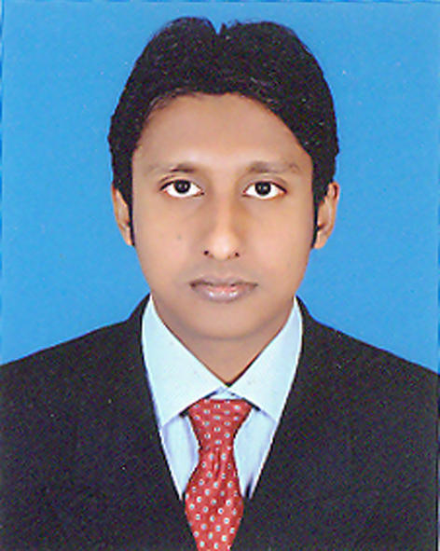
Career Objective | Aspiring for a challenging position to utilize my skills and abilities in the global industry that can also offer me professional growth while being resourceful, innovative and flexible
PERSONAL INFORMATION
Name | Ananda Kumar Shaha
Father Name | Subodh Chandra Shaha
Mother Name | Tulshy Rany Shaha
Permanent Address | Vill: - Par-Naogaon, P.O:- Naogaon-6500, P.S:- Naogaon Sadar,  District: - Naogaon, Division: - Rajshahi.
Gender | Male
Religion | Sanaton
Marital Status | Unmarried.
Date Of Birth | 01 May 1985.
Nationality | Bangladeshi
National ID No | 6426008173538
Blood Group | B+
Height | 5` 7``
CONTRACT INFORMATION
Present Address | House:-11, Road: -15, Nikonja-2, Khilkhet, Dhaka - 1229.
Contract Number | 01672963944
E-Mail | ananshaha@ymail.com

EDUCATIONAL QUALIFICATION
Secondary School Certificate S.S.C
Group | Science
Board | Rajshahi
School / College | Naogaon K.D Govt. High School, Naogaon.
GPA | 3.38 (Equivalent First Class).
Passing Year | 2001
Higher Secondary School Certificate H.S.C
Group | Science
Board | Rajshahi
School / College | Naogaon Govt. Degree College, Naogaon.
GPA | 3.60 (Equivalent First Class).
Passing Year | 2004
Business Of Bachelor Studies B.B.S
Major | Accounting
Institute | National University (Rajshahi College, Rajshahi)
Class | Second ( 57% )
Passing Year | 2008
Masters Of Business Studies M.B.S
Major | Accounting
Institute | National University (Govt. Titumir College).
Class | First Class ( 61% )
Passing Year | 2009
Cost and Management Accountant CMA
Level | Foundation
Institute | Institute Of Cost and Management Accountants Of Bangladesh (Dhaka)

EXTRA QUALIFICATION
Computer Skill | MS Office, Internet Browsing, E-Mail.
Certificate | Bangladesh Computer Council.
Language Proficiency | Fluent in both speaking and writing in English and Bengali.
Course | Writing course from S@ifurs.

REFERENCE
Prof. Netai Chandra Shaha.  Department Head Of Accounting (Retired)  Rajshahi College, Rajshahi.  Mobile no: - 01911970419. | Dr. Sukumar Shaha.  Associate Professor and Department Head,  Dept. Of Micro Biology & Hygiene,  Bangladesh Agricultural University,  Mymanshing-2202, Bangladesh.  Mobile no:- 01740847339

( Ananda Kumar Shaha )

