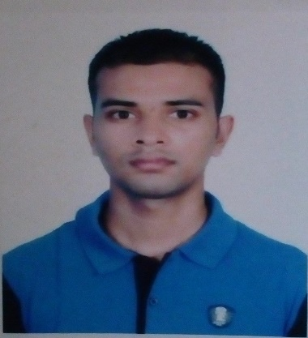
CARRICULAM VITA

Personal Information
1. Name : Md. Anwar Hossain
2.Father’s Name : Md.Sabed Ali
3.Mother’s Name : Most.Anjuara Begum
4.Date of Birth : 21 octobar 1998
5.Religion : Islam
6.Sex : Male
7.Maritial Status : unmarried
8.Nationality : Bangladeshi
9.Height : 5’-6”
10.National ID : 9154245352
11.Permanent Address : Vill:Shomvogau, P.O: Kollany Hat,
Thana:Birganj, Dist: Dinajpur.
12.Present Address : Binodpur bazer,Motiher,Rajshahi
13.Mobile : 01756886867
14.E-mail : mdanwarhossain21691@gmail.com

Educational Information
Secondary school certificated
Institute : Chowdhury Hat High School.
Passing Year : 2015
Group : Science
Result : GPA – 4.72
Board : Dinajpur

Higher Secondary Certificated
Institute : Dinajpur Govt. College
Passing Year : 2017
Group : Arts
Result : GPA-4.67
Board : Dinajpur

Higher Certificated
Institute : Rajshahi University.
Passing Year : Current Student
Department : Philosophy
Year/Semister :1st

Language competency
Speak,Read and write Fluently in Bangli, English

Experience:
Former lecturer :Icon choching Centre,2015-2017
Declaration:
I do hereby declare that the information provided above is undoubtedly correct and I will be responsible for any kind of wrong information.

Date: 30/03/2019
Sincerely yours
Md. Anwar Hossain

