Resume

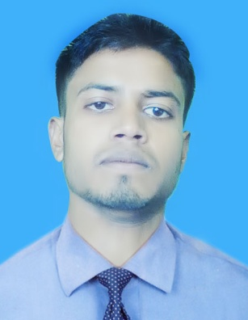

Of
Md. Zahidur Rahman

Md. Zahidur Rahman.
Satpua, Sarishabari, jamalpur
Mobile: 01772735101, 01624631900
E-mail:apuzahidur@gmail.com

Career Objective

To serve in a responsible position in a well-reputed organization where I can utilize my acquired managerial and interpersonal skills to enhance organizational efficiencies and achieve success thereby.
economy through the assigned duty.
Educational Details

Secondary School Certificate (SSC)
Institution : Sarishabari R.U.T high school.
Group : Science
Year of Completion : 2012
Board : Dhaka
Result : GPA 4.31 out of 5.00

Higher Secondary Certificate (HSC)
Name of Institution : Vatara Uchomadhomik School.
Group : Science
Year of Completion : 2014
Board : Dhaka
Result : GPA: 4.00 out of 5.00

B. S.C (Hons.)
Name of Institution : Gov.Ashek Mahamud collage.Jamalpur
University : National University.
Group+ Year : Botany.2nd year
Result : Stray In study.

Computer Proficiency
- Familiar with MS Word, MS Excel, MS PowerPoint, Photoshop, R programming & Internet browsing. 6 month course Completed.
- Good Knowledge about in Web design & development. 2month 20 days course Completed From (ledp).Jamalpur.

Language Proficiency

Good Communication skill in both Bengali and English.

Experiences

- Two year worked experience as a ``Computer Trainer” in Gov. Approved Perfect computer training center. sarisahabari,jamalpur.
- Two Year worked experience as a ‘ Office Assistance’ in Akij Corporation L.T.D , Sarishabari territory Oficee.
- Now I am Work as a ‘Computer Operator & Data entry Operator’ in a Non.gov. School

Personal Details

Name : Md. Zahidur Rahman
Father's Name : Late Safiqul Islam
Mother's Name : Nurzahan Begum
Permanent Address : Vill: Satpua, Post: Sarishabari, P.S.: Sarishabari,
Dist.: Jamalpur.
Date of Birth : 10th May, 1997
Nationality : Bangladeshi
Religion : Islam
Marital Status : Single
Sex : Male
Blood Group : A+
National ID card NO : 19973928501000028
Contact No : 01772735101, 01624631900
Abilities

- Strong Motivation, commitment and dynamic for work.
- Endurance to work for long hours and under pressure.
- Ability to work independently as well as a team member.
Certification

I, the undersigned, certify to the best of my knowledge and belief this resume correctly describes.

...............................
Md. Zahidur Rahman

