Curriculum Vitae

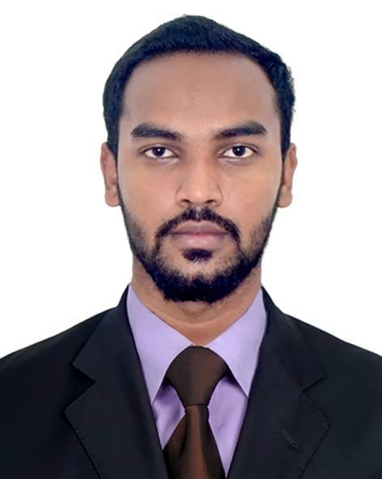

Cell: +8801671624758  E-mail: athikrahman6@gmail.com | Atikur rahman  Giash nagar,Moulvi Bazar

Objective

To work with an organization where I can utilize my educational qualifications as well as my personal and interpersonal skills to the maximum uses and thereby play a significant role to personal & organization growth and build my career as an effective personnel.

Strengths

- Hard working
- Good communication skills
- Quick learner

Summary of Skills

- Platforms:

Windows Platforms (Windows 98/ME/XP/2000/7/8/8.1/10)

Language Proficiency
Excellent command and writing capability in Bengali & English both.

Others

Proficient in Microsoft Office Applications.
Proficient in Hardware Skills .
Experience

As a Teacher Of Islamia Academy.(Moulvi Bazar)
As a Field Supervisor of ORG-Quest.(NGO)
As a Data Entry Officer of Dekko Accessories Ltd

Academic Qualifications

- Master Of Business Administration (MBA)
Duration : 2 Years (Session 2018-2020)
Passing year : 2020
Result/Status : Running Student
University : Metropolitan University,Sylhet

- Bachelor of Science in Computer Science and Engineering (B.Sc.)
Duration : 4 Years (Session 2013-2016)
Passing year : 2017
Result/Status : 2.62 out of 4
University : Metropolitan University,Sylhet .

- Higher Secondary Certificate (H.S.C.)
Stream : Science
Duration : 2 Years (Session 2010-2011)
Result/Status : 3.70 out of 5
Passing year : 2012
College : Moulvi bazar Govt. College, Moulvi bazar.
Board : Sylhet
- Secondary School Certificate (S.S.C.)
Stream : Science
Duration : 2 Years (Session 2008-2009)
Passing year : 2010
Result/Status : 3.81 out of 5
School : Pourashava adarash High School, moulvi bazar.
Board : Sylhet

Personal Details

Name : Md.Atikur Rahman
Father’s Name : Md.Ashid Ali
Mother’s Name : Nurjahan Begum
Sex : Male
Marital Status : Single
Nationality : Bangladeshi
Date of Birth : 3rd jan, 1994
Permanent Address : C/O- Ashid Ali
Giash nagor, Moulvi bazar-3200, Bangladesh
Contact Address : Md.Atikur Rahman
Giash nagor, Moulvi bazar-3200, Bangladesh
Cell No. : +8801671624758,+8801768322774
E-mail : athikrahman6@gmail.com

Note:
I, hereby confirm that, all the information stated above are fully correct according to the best of my knowledge.
……………………….
Atikur rahman

