Most. Najmin Chowdhury

Address: Munsirgown, Bethsandi-3100, Bishwanath, Sylhet
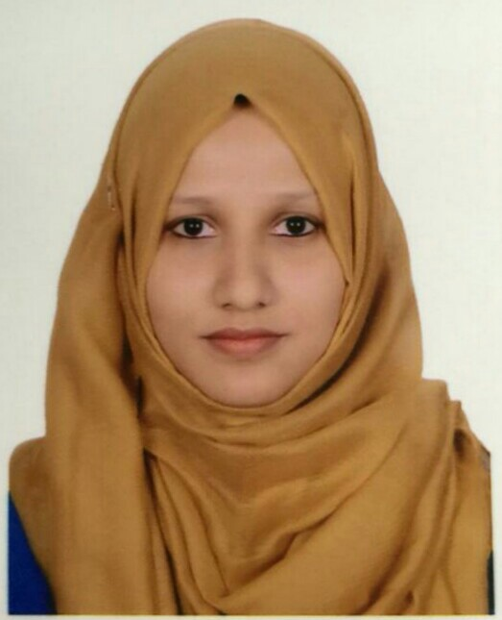
Contact: 01785820561
Email: fahmidanajminchy487@gmail.com

CAREER OBJECTIVE
Seeking an entry-level position to begin my career, where I can utilize my skills and academic studies background to the maximum.
ACADEMIC QUALIFICATION
Hons. on Social Work from Sylhet Govt. Womens College in 2019 with CGPA of 3.18.

HSC in Humanities from Sylhet Govt. Womens College in 2014 with GPA 4.10.

SSC in Humanities from Haji Yasin Ullah High School in 2012 with GPA 4.81.

CO-CURRICULAR ACTIVITIES
Having Fieldwork for 2 months from Sarkari Shishu Paribar,Department of Social Services,Ministry of Social Welfare,Raynogor,Sylhet

LANGUAGE SKILLS
Fluent in Bangla and full working knowledge in English.
IT SKILLS
Having training from National Youth Development Training Center (NYDTC) on MS Word, Excel, PowerPoint, Access, Internet & E-mail .
STRENGHTS
Public speaking, presentation skills, pro-active, team worker, leadership skills, capable of following instructions, hardworking and honest.
REFERENCES

1. Mohammad Abdul Wadud Chowdhury
Deputy Secretary, Cabinet Division,
Government of the People’s Republic of Bangladesh,Dhaka-1000
Mobile : 01711047882
E-mail : wadud1975@gmail.com

2. Mohammad Zillur Rahman
Assistant Professor,
Dept. of Social Work,
Sylhet Govt. Womens College.
Mobile : 01712734706

I accept that all the information provided above is true to the best of my knowledge.

(Name of Candidate)

