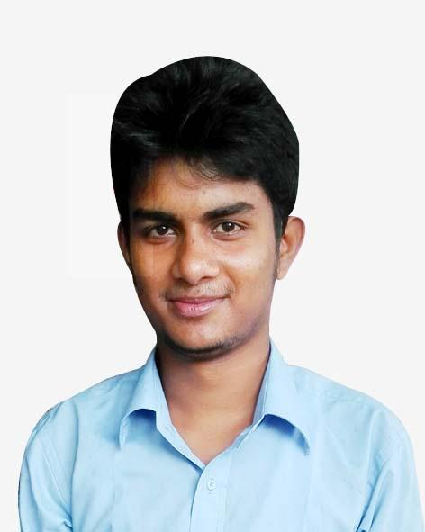
Resume of
MD: Azim Uddin Munna

Mailing Address :

Address : Section-11,Av-3,Block-C,Len-4,House-14,Mirpur,Dhaka-1216
E-mail : azim2562@gmail.com, Mobile: +8801558967813,Skype:azim2562

Objective:

To begin my career at a highly- reputed company and to give exceptional career move ahead though long efforts and performance regularly.

Competences:

- Sincere, Honest and Dedicated
- Willingness to take challenge
- Excellent communication skill
- Co-Operative and willing to work in a team
- Excellent interpersonal skill
- Enthusiastic.

Computer Literacy:

- Front-End Developer
- Wordpress Web Developer
- Microsoft Office, Excel .
- Internet Browsing.
- Photography, Adobe Photoshop.

Skill

Programming Language

- JavaScript
- PHP.
- C

Additional Skill

- HTML5
- CSS3
- Bootstrap
- Jquery
- Wordpress Development
- SEO
- Graphics Design

Certifications

- TemplateMonster WordPress Certification Center-2019
http://bit.ly/2PafrEZ
- TemplateMonster HTML CSS Certification Center-2019
https://bit.ly/2V3NwMe

Portfolio :

- Web developer & designer www.plwatches.com
- Web developer & designer https://www.perfectimepiece.com/
- Front End Developer at http://client.phafex.com/balun/
- Front End Developer at http://hei-homes.phafex.xyz/index.html
- http://themeforest.phafex.com/partex/
- https://azim-munna.github.io/E-Commerce/
- http://client.phafex.com/nikki/
- http://client.phafex.com/vendor_html/
- http://client.phafex.com/requrement/
- http://client.phafex.com/madison/
- GitHub ( https://github.com/Azim-Munna/ )

Experience :

- Front End & wordpress Developer at Phafex
(September 25, 2017 to present )

Educational Background:

B.Sc in Electrical & Electronics Engineering

Institute : Northern University Bangladesh.
Department : EEE
Academic Status : 5th Semester (Running)

Diploma in Electronics Technology

Year of Passing : 2017
Result/CGPA : 3.36 Scale of 4.00
Department : Electronics
Institute : Lakshmipur Polytechnic Institute
Board : Bangladesh Technical Education Board (BTEB)

Secondary School Certificate (S.S.C)

Year of Passing : 2012
Result/GPA : 4.46 Scale of 5.00
Department : Electrical
Institute : Lakshmipur Technical School and College, Lakshmipur
Board : Bangladesh Technical Education Board (BTEB)

Language Proficiency:

Bengali : Well in writing and speaking
English : Well in writing and speaking

Self Profile:

Name : MD: Azim Uddin Munna
Father’s Name : Kamal Uddin
Mother’s Name : Arzu Begum
Date of Birth : 04 mar 1997
Nationality : Bangladeshi
Religion : Islam
Marital Status : Unmarried
Blood Group : O+
Height : 5'-8"
Weight : 65kg

Permanent Address:

C/O : Abul kalam bari, Vill :Borovollovpur ,
P.O : boroytola, P.S : chandrogonj, Dist : Lakshmipur.

Declaration:

I do hereby declare that the above written particulars are true, the Best of my knowledge and belief.


Date : 15-04-2019 | Signature

