CURRICULUM VITAE
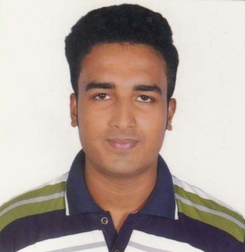
OF
Babon ghosh
Cell: 01911-181888

Permanent Address:
C/O: Poritosh Ghosh
Vill : Birampur, P.O: Education Board,
P.S : Kotwali, Dist: Jashore.

Career Objective:
To work in a Vision oriented organization using Managerial ability to help the Form
to achieve goals and gaining managerial Skill Through hard Work, Contemporary
management Practice is the main focus of career.

Educational Qualification:

B.B.A (Hon’s): (Accounting)
Institute : Cantonment college , Jashore.
Subject : Accounting
Board : National University
Year : 2015.

Result : CGPA 2.85

Higher Secondary Certificate (H.S.C):
Institute : Abdur Razzak Municipal College, Jashore.
Group : Business Studies
Result Obtained : GPA 3.70
Board : Jashore
Year of passing : 2013

Secondary School Certificate (S.S.C):
Institute : Shela Roy Chowdhury Secondary School.
Group : Business Studies
Result Obtained : GPA 3.81
Board : Jashore
Year of passing : 2011

Communication Skill:

Language Speaking Writing Reading
English Good Good Good
Bangla Excellent Excellent Excellent

Personal Information:

Name : Babon Ghosh
Father’s Name : Poritosh Ghosh
Mother’s Name : Krishna Ghosh
Present Address : Vill- Birampur, P.O- Education Board
P. S- Kotwali, Dist- Jashore.
Permanent Address : Vill- Birampur, P.O- Education Board
P. S- Kotwali, Dist- Jashore.
Home District : Jashore.
Date of Birth : 03/10/1996
Nationality : Bangladeshi
National ID No : 6863701691
Religion : Hindu
Blood Group : “A+” (Positive)
Marital Status : Unmarried
Sex : Male
E-mail : babonghosh.bd@gmail.com

Computer Skills:
MS Office, Internet Browsing , Email, Photoshop and Social Media.

Confidence:
I am smart, young, energetic, an outgoing pleasant personality and self started strong
Inter personal skill an ability to work at a high peace on one’s imitative.

Signature

......……………………
Date: .......................... (Babon Ghosh)

