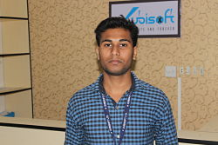
Personal Information

Name : Bapon Bhowmik
Father Name : Babul Bhowmik
Mother Name : Sulakha Rani Bhowmik
Nationality : Bangladeshi
Contact No : 01773136951
Email : baponbhowmik51@gmail.com
Date of birth : 07-12-1996

Career Objectives:

Myself Bapon Bhowmik. .I have completed Diploma in Computer Technology from Sylhet Polytcehic Institute. Now I am trying to establish my career in It and telecommunication sector as I feel there is lot of opportunity . I also realize that my skills does suits this particular sector .

Educational Qualification:

Exam/Degree | Grade/CGPA | Board/university | Passing Year
S.S.C | 3.94 | Sylhet | 2014
Diploma in Computer Technolgy | Appeared | Sylhet Polytechnic Institute | 2018

Experience:

After completing the diploma I have completed a 3 month internship on Networking and Linux administration from Xubisoft LTD Dhaka

Technical Skills:

→ Linux Setup
→ Networking
→ Hardware maintenance & servicing
→ Marketing
→ Graphics Design
→ Microsoft Excel,Word,Power point
→ Operating System: Windows 7,Windows xp

