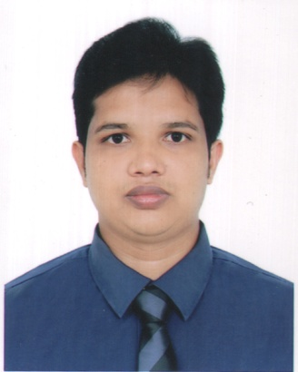

CURRICULUM VITAE
OF
MA.Tanvin ibna Mahmud
Cell: +88 01766546544
E-mail: tanvinbappa52@gamil.com
Career Objectives:
To build up a dynamic career in Law filed where I can demonstrate my technical and managerial skills and contribute to the organization by working in a friendly & challenging environment with ample prospects for growth .

Self Appraisal:
* Good as a team member.
* Punctual, hard wording and Energetic .
* Amiable and Friendly,
* Honest, Reliable, Self-motivated and diligent
* Excellent communication skill (oral and written) and Interpersonal skill.

Academic Qualification:

Degree | : | LL.M
Subject | : | Bachelor of law
Institute | : | Europen University of Bangladesh
Duration | : | One Year’s
Result (C. G.P.A) | : | 3.00

Degree | : | LL.B (hon’s)
Subject | : | Bachelor of law
Institute | : | Europen University of Bangladesh
Duration | : | Four Year’s
Result (C. G.P.A) | : | 3.10 out of 4.00
Degree | : | Higher Secondary Certificate (H.S.C)
Institute | : | Pathraj College, Panchagarh.
Board | : | Dinajpur
Group | : | Business Study
Year of Passing | : | 2010
Result(G.P.A) | : | 2.10 out of 5.00
Degree | : | Secondary School Certificate (S.S.C)
Institute | : | Boda pilot High School
Board | : | Rajshahi
Group | : | Science
Year of Passing | : | 2008
Result(G.P.A) | : | 3.69 out of 5.00

Computer Skill:
MS Word, MS Excel, Power Point, Web Browsing and E-mailing.

Language Proficiency:

Language | Writing | Reading | Listening | Speaking
Bengali | Excellent | Excellent | Excellent | Excellent
English | Excellent | Excellent | Excellent | good
Experience:

- Worked at ACI Group (Shwapono)
From (05.01.12 to23.03.13)
Post.Super viser in shwapono.

Woking at Rahim Afroz Supre stores Ltd. (Agora)
From (30.3.13 to31.12. 16)
Post. Customer Service Assistant.

Working at Rang Electronics Ltd. 2017 till now,
Form join(08.02.17) till now.
Post.Seals officer in-charge CTP.

c
Personal Information:

Father’s Name | : | Md.Nazrul Islam
Mother’s Name | : | Mazda akter
Date of Birth | : | 21 Decembor 1992
Sex | : | Male
Religion | : | Islam
Marital Status | : | Single
Blood Group | : | B+
Height | : | 5' 7''
Nationality | : | Bangladeshi

Permanent Address:

Village | : | Nogorkumari
Post | : | Boda
P/S | : | Boda
Dist | : | Panchagarh

Present Address: Bosila Road #2 House # 12, Mohammadpur, Dhaka-1207

Reference:
1. | J.K.Baral  Executive Director  Interated Service for Development of Children & mothers.  West Agargaon  Sher-E-Banglanagar,Dhaka-1207  Contact No. +8801755559642
2. | Md. Mashiar Rahman  Igeneral mznager & Team leader,ENRICH  Palli Karma-Sahayak Foundation(PKSF)  Agargaon Administrative Area  Sher-E-Bangla nagar,Dhaka-1207
Contact No.+8801711819926

Declaration:
I do hereby declare that all of my information stated above in this curriculum vitae are true the best of my knowledge and belief.

Date: Signature:

