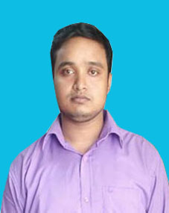
CURRICULUM VITAE

OF

AROBINDU CHANDRA BARMAN

CALL:+8801728617294

Email : arobindu12@gmail.com

CAREER OBJECTIVE:

Willing to build up career in a challenging position and to prove myself as a quick learner and highly energetic person to face any challenge in the information computer technology where the contribution will be acknowledged, if would be given an opportunity.

ACADEMIC QUALIFICATION:

- Diploma-in-Engineering:
  - Institution : Rangpur Polytechnic Institute,Rangpur.
  - Group :Computer.
  - Result : 2.96 (out of 4.00).
  - Passing Year : 2016.
  - Board : BTEB.
- Secondary School Certificate (S.S.C)
  - Institution : Kaligonj high school.
  - Group : Science
  - Result : GPA- 4.75(out of 5.00).
  - Passing Year : 2011.
  - Board : Dinajpur.
ACHIEVEMENTS:
- Strong communication and interpersonal skills.
- Good analytical and problem solving skills.

COMPUTER SKILLS:
- Microsoft Windows, Office (MS Word, Excel, Power Point )
- Hardware Maintains and Troubleshooting , Network Sharing
- Printer Sharing

INDUSTRIAL TRAINLNG:

- Genuity System Ltd. : Professional Networking

LANGUAGE SKILL:
- Bangla (Good).
- English (Medium).

Relevant Skills:
- Capable of working in a team as well as independently.
- Comfortable with working long hours in the lab as well as an organization.
- Fluent in speaking, writing & listening in both English and Bengali.

PERSONAL INFORMATION:
Name :Arobindu Chandro Barmon
Father’s Name : Anil Chandro Barmon
Mother’s Name : Minati Rani
Religion : Hindu
Sex : Male
Marital status : Unmarried
Date of Birth : 20/12/1995
Nationality : Bangladeshi (by birth)

PERMANENT ADDRESS:
Permanent Address : Vill: kaligonj.
Post office :Itakumary
Police station : Pirgachha.
Dist : Rangpur.

Declaration:
I do hereby declare and certify the information stated above in this curriculum vitae are true and complete the best of my knowledge and belief.

Signature

AROBINDU CHANDRA BARMAN

