To
The HR Manager

PBDF

Sylhet Branch, Sylhet.
Subject: Application for Job.
Sir,
I come through the advertisement given by your company in the job website “Thousand Careers”. It provides a wide range of program and also helps to create ambitious & prospective leaders in the market. For the reason I need the job.
I recently finished my post-graduation from Leading University, Sylhet.

I therefore pray that you would be kind enough and give me the opportunity to select me for the job & oblige thereby.
Yours Faithfully
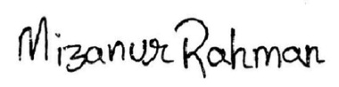
………….……………
Mizanur Rahman
Date:21.12.2017

