Resume
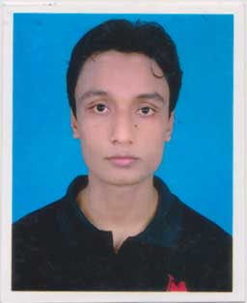
Mahabub Wadud Mahi
Mobile Number: 01835925497
E-mail id: mahabubwadudmahi6@gmail.com
Address: 71, South Kamalapur, Motijheel,
Dhaka.

OBJECTIVE

My objective is to work in a dynamic working environment where the opportunity to take challenges will be available. I want to make sure that my educational know-how will be utilized with optimum potentiality. I also want to do something better for the organization with self-knowledge, creativity and hard work.
Certification
- Certification course in computer Official. (MS Word, MS Excel, Browsing, Online)

Job experience

BANGLADESH TRANSLATION PVT. LTD.
Duration: From 2018 August also Running .
Position: Computer Operator.

KDS
Duration: From 2017(3 month do this job).
Position: Receiver.
Educational Background

National University
(B.S.S) Major in Political Science.
Institute : Bijoy Smarani University College.
Board : Chittagong.
Section : 2013-14.
Higher Secondary Certificate
(H.S.C) Humanities.
Institute : Sitakund Degree College.
Board : Chittagong.
Passing Year : 2013.
Secondary School Certificate
(S.S.C) Business Studies.
Institute : Jafar Nogor A.C. High School.
Board : Chittagong.
Passing Year : 2011.

Language Skill

English and Bengali.

Interests

Traveling, Reading, Internet browsing.

Personal Details

Father’s Name : Abdul Wadud.
Mother’s Name : Parvin Akther.
Present Address : 71, South Kamalapur, Motijheel, Dhaka.
Permanent Address : Vill: North Kather Khill, P.O: Jafar Nogor,
P.S: Sitakund, Dist: Chittagong.
Date of Birth : 05th Jun 1994.
Nationality : Bangladeshi (by Birth).
Gender : Male.
Marital Status : Single.
Religion : Islam.
Place of Birth : Chittagong, Bangladesh.


……....................................
Signature
(Mahabub Wadud Mahi)

