Resume of 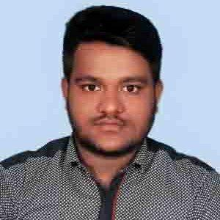
Md.Emran Hossain
Charakhali.Rajapur.Jhakhati
Mob.01747 496983
Gmail.khanmdimran2020@gmail.com

Career Objective:
To obtained a standard job in any well-known organization where I can apply my creative skills and competency.
Personal Details:
Name : Md. Emran Hossain.
Father’s Name : A. Razzaq Shikdar.
Mother’s Name : Mst. Rany Begum
Date of Birth : 15th June, 1994
Nationality : Bangladeshi
Blood Group : A+
Marital Status : Unmarried
Permanent Address : Vill: Charakhali, P.O: Galua.
P.S: Rajapur, Dist: Jhalakhati.

Educational Background:

Examination  Name | Group | Board | Passing Year | GPA | Scale
H.S.C | Humanities | Barisal | 2012 | 3.30 | 5.00
S.S.C | Humanities | Barisal | 2010 | 3.63 | 5.00

Professional History:
Company name : Esquire Knit Composite Ltd.
Address : Kanchpur, Sonargaon, Narayangonj.
Designation : CAD Operator (Pattern & Marker)
Section : Sample & Technical
Duration : 14th August 2014 up to till now

Working Skill:

- Marker making for bulk production by using LECTRA Software.
- Calculating actual marker consumption for bulk production by manually and using formula of Microsoft Excel.
- Calculating sewing thread consumption
- Calculating consumption of interlining and silicon tape.
- Calculation measurement of any of Poly and Carton.
Computer skill:
- Windows Operating System: XP, 7 Ultimate, 10.
- MS Package: MS Word, MS Excel, MS PowerPoint.
- Internet browsing and Email communication.
Language Skill:
- Bengali: Excellent in speaking, reading and writing.
- English: Fluently speaking, reading and writing.
Interest:
- Reading novel and humorous story
- Travelling, watching movies, enjoying songs.
- Playing sports such as cricket, football, badminton.
Reference:
Md. Nazrul Islam Liton Md. Nasir Uddin
Manager Asst. Manager
Sample & Technical Sample & Technical
Esquire Knit Composite Ltd. Esquire Knit Composite Ltd
01713-333053 01709-636084
E-mail: liton.cad@esquirebd.com E-mail: nasir.cad@esquirebd.com

Signature………………
Md. Emran Hossain
Date:

