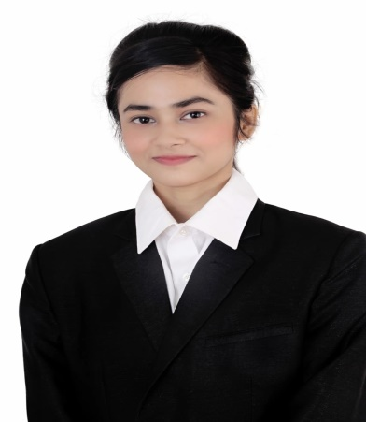
CURRICULUM VITAE
OF
Tasfia Ahmed Kamaly Suhi
tashfiaahmed1999@gmail.com

Akhalia, Sylhet.
Mobile: +88 01761982772

OBJECTIVE
To upgrade myself as an efficient, honest & diligent person in a wonderful environment from where I will get guideline to build a challenging career. My promise, drive & attitude deserve sophisticated job in an institution, which can guide me face challenges of the new millennium.

EDUCATION QUALIFICATION

Institution :Leading university . Sylhet
Subject :Bachelor of Business Administration

Name of Exam : Higher Secondary School Certificate (HSC)
Institution : Scholarshome Girls School & College, Sylhet
Board : Sylhet
Year of Passing : 2019
Result :3.33

Name of Exam : Secondary Certificate (SSC)
Institution : Patantula dipakkhik school & College Sylhet
Board : Sylhet
Year of Passing : 2017
Result :3.83

COMPUTER SKILL:
03 month IELTS COURSE
Microsoft excel
Microsoft office
Microsoft office power point
03 Month Basic Computer Course from U.K ICT INSTITUTE.

EXPERIENCE:

- International Workshop on communication skills 2018
- National English Olympiad 2018

LANGUAGE PROFICIENCY
Bangla Good in speaking, writing, reading and listening.
English Good in speaking, writing, reading and listening.

PERSONAL Information
Name : Tasfia Ahmed Kamaly Suhi
Father’s Name : Tufayel Ahmed Kamaly
Mother’s Name : MST.Rowshan Ara Chowdhury
Present Address : 4/4,nuapara,Akhalia
Permanent Address: Vill:Shaharpara,P.S:jagannathpur
P.O:Shaharpara bazar ,Dist:Sunamganj
Date of Birth : 30/09/1999
Religion : Islam
Marital Status : Unmarried
Sex : Female
Nationality : Bangladeshi (by birth)
Blood Group : B⁺

suhi

Signature & Date

