CURRICULUM VITAE
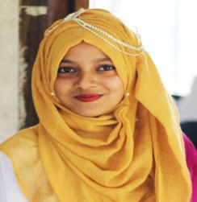
Name :Jesmin Akter Rani
Fathers’s Name :Azizur Rahman Aziz
Mother’s Name :Jusna Begum
Date of Birth :10-12-1998
Marital Status :Unmarried
Nationality :Bangladeshi
Gender :Female
National Id No :3305174504
Religion :Islam
Present Address :30 Shornoshikha ,kadamtaly ,Sylhet
Parmanent Address :30 Shornoshikha ,kadamtaly ,Sylhet
Mobile No :01759-828463
E-mail :tafsiar@gmail.com
Career Objective:
I aspire for a challenging position in aprofessional environment where I can enhance my skills and strengthen in conjunction with organization’s goals.A self-motivated achiever with an ability to plan execute.
Academic Qualification:
Exam title | Institute | University/Board | Result | Pass year
SSC | SYLHET GOV’T AGRAGAMI GIRL’S HIGH SCHOOL&COLLEGE,SYLHET | SYLHET | 5.00 | 2014
DIPLOMA IN CSE | SYLHET POLYTECHNIC INSTITUTE,SYLHET | SYLHET | 3.48 | 2018
Traning Summary:
Traning Title | Topic | Instiute | Country | Year | Duration
Advanced certificate in computer application | MS word,MS excel,MS powerpoint | Sylhet technical traning center,sylhet | Bangladesh | 2016 | 6 month
Web design | Html5,css3,bootstrap | Nano-it | Bangladesh | 2018 | 4 month

Other skills:
- Language fluency in English.

