Résumé of
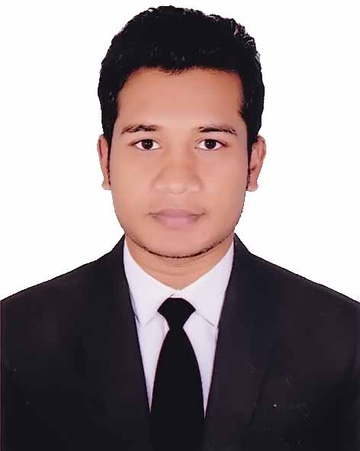
MOHAMMAD RAFIKUL ISLAM

House-20, Road-14,Nikunja-02,

Khilkhet, Dhaka-1229.

Mobile No: +8801734305742
E-mail: kironkhan222@yahoo.com

Career Objective:

Looking for a dynamic and challenging job to utilize my background and willing to work in a creative and technical environment where there are scope to utilize knowledge and creativity.

Employment History

- AKHTAR GROUP/FURNISHERS( 01 years )
- Executive Corporate Sales ( join Date 05,January 2016)
- Corporate Office,66 Progoti Sharani,Baridhara,Dhaka-1212.
Total Year of Experience: 4 Years.
- HR Officer (Join Date: ^{1st} January 2012 to 31 December 2015.)
- Thermax Group Lt. Company Location: Narsingdi.
Duties/Responsibilities:
- Monthly Statement of staff, officer and worker joining, Migration and increment/promotion.
- Assist to formulate manpower planning,
- Assist in maintaining overall floor compliance housekeeping, health and safety, employee welfare, transport and canteen.
- To maintain the employees personal file with all related papers as up-dated.
- To follow up worker & Staff attendance and Production floor follow up,
- To maintain office entertainment and canteen.
- Maintain all data records papers in relation to Recruitment & selection, wages, OT and allowance
- Leave from Posting, Earn Leave Posting, File Making
- Monitor worker/.staff /officers in/out time and maintain a record of the late comers.

Computer Skill Operating System :
- M.S office : Word, Power Point, Excel, Access
- Scheduling Tools : M.S Project- 2007.
- Programming Language : C & C⁺⁺. Windows XP, Windows7
Have basic knowledge on computer Networking
Linguistic proficiency:

- Have an excellent command over English and Bengali languages in both Speaking and writing.
Communication Skills
- Proficient in oral and written communication both in English and Bengali.
- Able to communicate effectively with all both on technical and non-technical levels.

Key strength
- Strong appetite for leading & honest life & dignity.
- Aspiration to a career showing superior performance.
- Hard working, sincere & eager to learn.
- Ability to take responsibility.

Academic Background

(Masters )
Institution : Gov’t Titumir College.
University : National University
Year of passing : 2012
Subject : Political Science
Result : 2nd Class

Honour’s
Institution : Narsingdi Gov’t College.
University : National University
Year of passing : 2011
Subject : Political Science
Result : 2nd Class

Higher Secondary School Certificate (HSC)
Institution : Taragonj H N High School and College.
Board : Dhaka
Year of passing : 2007
Group : Humanities
Result : 3.70 Out of 5.00

Secondary School Certificate (SSC)
Institution : Damra Dhakil Madrasha.
Board : Madrasha
Year of passing : 2005
Group : Humanities
Result : 2.92 Out of 5.00.

Personal Information:
Father’s Name : Mohammad Ikbal Hosain
Mother’s Name : Shiria Begum
Date of Birth : 12/11/1988
Height : 5 feet 9 inches
Marital Status : Un-married
NID No : 19883313494760282
Religion : Islam (Sunni)
Nationality : Bangladeshi (By birth)
Permanent Address : Village- Mokterpur, P.O: Shaoriad Ba
P.S: Kaligonj, Dist: Gazipur

References .
Abdul Kadir Rubel Mridha
Asst. Manager (Accounts & Finance)
United Shipping Lines Ltd.
National Plaza (4th Floor)
109, Bir Uttam CR Dutta Road, Dhaka-1205
Cell : 01612-239639, 01818-832733
E-mail: kadir10mth@

Md. Abdullah Al-Mamun
(Asst. Manager HR & Comp)
Thermax Yarn Dyeing Ltd.
Karardi, Shibpur, Narsingdi.
Cell: 01811415446



……………...
(MOHAMMAD RAFIKUL ISLAM
Date:

