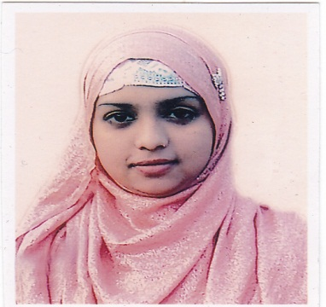
Resume of
Jannatul Ferdous Trishna
Present Address:  House no : 63 Rongdonu,  chowkidhi  Sylhet, Bangladesh | Contact Address:  E-mail :jannattrishna1402@gmail.com  Cell Phone : +880-1670538811

Objective
Objective

To obtain a responsible position through which I can utilize my knowledge, enhance my skills as well as can acquire the ability to face a high level of challenges, and get myself provided with varied experience and at the same time I would like contribute my best to the organization.
Educational Qualifications

B.S.C (Hon’s) in ‘Computer Science & Engineering’(C.S.E):
Session : 2010-2014
CGPA : 3.12 (Approx. Out of 4)
Class / Division : First Class
Metropolitan University, Sylhet, Bangladesh.

Higher Secondary Certificate (H.S.C):
Group : Science
Passing Year : 2009
GPA obtained :3.40 (Out of 5)
Class / Division : First Division
Blue Bird School & Collage, Sylhet Board.

Secondary School Certificate (S.S.C):
Group : Science
Passing Year : 2007
Class / Division : First Division
GPA obtained : 4.13 (Out of 5)
Amborkana School & Collage, Sylhet Board.

Computer Knowledge

- Having sound Knowledge HTML5, CSS, PHP, C, Jqurary , javascript, Wordpres Etc.
- Able to prepare any type of documents with MS word, MS Excel, MS Access.
- Able to prepare any type of slide with MS power point.
- Able to work with Statistical Software SPSS (Statistical Product and Service Solutions)
- Having knowledge on Internet browsing and e-mail.

Language Proficiency

- Bengali: Good communication & presentation skills in Bengali
- English: Good communication & presentation skills in English

Self Assessment
- Strong desires for leading an honest life with dignity.
- Aspiration to build a career showing superior performance.
- Energetic, Sincere, Hard working, Honest and Dutiful.
- Ability to work with a team.

Personal Profile

Name : Jannatul Ferdous Trishna
Father’s Name : S.M.Aktheruzzaman
Mother’s Name : Rina Akther
Permanent Address : Vill: Anderkuta, Post: Galimpur,
Upozilla: Nowbabgong, District: Dhaka, Bnagladesh.
Date of Birth : Mar 08, 1991
Contact Number : +880-1670538811
Nationality : Bangladeshi (By Birth).
Religion : Muslim (Sunni).
Marital Status : Unmarried.

Working Experince:

- Five month working Experence as a ICT Lecturer at Sylhet Pioneer School & collage.
- Working at Softcraftbd From February 2015 – March 2016.
- Working as a ICT Lecturer at Jalalabad Univercity Collage ,Sylhet From ( June 2015 - Present )

References :

1. Dr : Md Ashraful Islam Arif

North East medical College, Sylhet.
Mobile : 01610 538811

2. MD : Jakir Hossain

( Senior Lecturer Dept of CSE )
Metropolitan University, Sylhet.
Mobile : 01199 299712

Yours Sincerely,

(Jannatul Ferdous Trishna)

