Curriculum Vitae
Farhan Masud Buiya  Contact: 01615046730, 01785046730  Email: farhan.parves@gmail.com  Present Address: Bhuiyan Bari, Lakhaura Airport, Sylhet, 3100 | 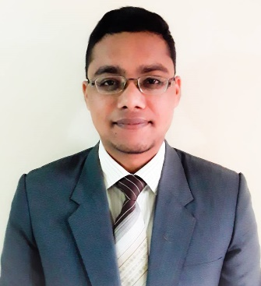

Career Objective:
As a human I try to give my level best effort for your institute, as a computer engineer to apply technical knowledge, expand skill set and contribute to the goals of the institute. And as an ongoing radio jockey in Bangladesh Betar, Sylhet I will give my best idea and different knowledge from my five (5) years experiences.

Detailed Information:
Father Name: Borhan Uddin
Mother Name: Parvin Akther
Date of Birth: 11th march 1996
Nationality: Bangladeshi (By Born)
Religion: Islam
Marital Status: Single
Permanent Address: Bhuiyan Bari, Lakhaura Airport, Sylhet, 3100
District: Sylhet

Educational Qualification:

2015-2018 Bachelor of Computer Science and Engineering [B.Sc (Engg) in CSE]
Final year exam candidate
Department of Computer Science and Engineering
GPA: 3.30 out of 4.00 (Till 4th year final semester)
Class :- First Class
Institution: North East University Bangladesh, Sylhet
2011-2013 Higher Secondary Certificate (HSC)
Group: Science
Board: Sylhet
GPA: 3.90 out of 5.00
Division: First Division (According National Scale)
Institution: Madan Mohan College, Sylhet
2009-2010 Secondary School Certificate (SSC)
Group: Science
Board: Sylhet
GPA: 4.19 out of 5.00
Division: First Division (According National Scale)
Institution: Pacchim Sadar High School, Sylhet

Skills set:
    - Knowledge in my field: C, Python, Java, HTML, Networking, Troubleshooting
    - Office Applications: Microsoft office.
    - Verbal Skill: Very Good
    - Communication Skill: Very Good
    - Management Skill: Very Good
    - Language: Bengali and English

Extra circular activity:
    - Working experience in Radio Doorbin (online)
    - Working experience in Radio Sylhet (online)
    - Currently working in Radio Sylhet FM-105.2 as Radio Jockey (Govt. Station) since 2013
    - The former treasurer of Radio Announcer’s Club, Sylhet
    - Current Promotional and Office secretary of Radio Announcer’s Club, Sylhet
    - Drama artist and program designer at BD Betar Sylhet.
    - I also design special program for eid and special occasion.

Software Project:
Restaurant Management Software, Puzzle Game, FIFA World Cup Winner prediction 2018

Achievement:
- Got 3rd position in 1st semester programming contest
- Got 2nd position in 1st year programming contest
- 5th position in government A2i project (Govt. Project).
- Champion Inter Department Debate Competition
- Best debater and debater of tournament Inter Department Debate Competition.

Strength:
- Able to work well under pressure
- Able to take on responsibility
- Team work skill
- Well management power
- Quick learner, keep to learn and improve skill

I declare that to the best of my knowledge and belief, this information is accurate and correctly describe me and my qualifications.

Farhan Masud Buiya
21.12.18

