Curriculum Vitae
Farhan Masud Buiya  Contact: 01615046730, 01785046730  Email: farhan.parves@gmail.com  Present Address: Bhuiyan Bari, Lakhaura Airport, Sylhet, 3103 | 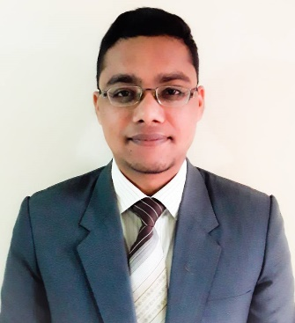

Career Objective:
As a human I try to give my level best effort for your institute, as a computer engineer to apply technical knowledge, expand skill set and contribute to the goals of the institute. And as an ongoing radio jockey, drama artist and script writer in Bangladesh Betar, Sylhet I will give my best idea and different knowledge from my five (5) years experiences.

Detailed Information:
Father Name: Borhan Uddin
Mother Name: Parvin Akther
Date of Birth: 11th march 1996
Nationality: Bangladeshi (By Born)
Religion: Islam
Marital Status: Single
Permanent Address: Bhuiyan Bari, Lakhaura Airport, Sylhet, 3103
District: Sylhet

Educational Qualification:

2015-2018 Bachelor of Computer Science and Engineering [B.Sc (Engg) in CSE]
Passing Date: 21/01/19
Department of Computer Science and Engineering
GPA: 3.28 out of 4.00
Class :- First Class
Institution: North East University Bangladesh, Sylhet
2011-2013 Higher Secondary Certificate (HSC)
Group: Science
Board: Sylhet
GPA: 3.90 out of 5.00
Division: First Division (According National Scale)
Institution: Madan Mohan College, Sylhet
2009-2010 Secondary School Certificate (SSC)
Group: Science
Board: Sylhet
GPA: 4.19 out of 5.00
Division: First Division (According National Scale)
Institution: Pacchim Sadar High School, Sylhet

Skills set:
    - Knowledge in my field: C, Python, Java, Networking, Troubleshooting
    - Office Applications: Microsoft office.
    - Verbal Skill: Very Good
    - Communication Skill: Very Good
    - Management Skill: Very Good
    - Language: Bengali and English

Extra circular activity:
    - Working experience in Radio Doorbin (online)
    - Working experience in Radio Sylhet (online)
    - Currently working in Bangladeah Betar Sylhet FM-105.2 as a Radio Jockey (Govt. Station) since 2013
    - The former treasurer of Radio Announcer’s Club, Sylhet
    - Current Promotional and Office secretary of Radio Announcer’s Club, Sylhet
    - Enlisted drama artist and program designer at BD Betar Sylhet.
    - I also design special program for eid and special occasion.

Software Project:
Restaurant Management Software, Puzzle Game, FIFA World Cup Winner prediction 2018

Achievement:
- Got 3rd position in 1st semester programming contest
- Got 2nd position in 1st year programming contest
- 5th position in government A2i project (Govt. Project).
- Champion Inter Department Debate Competition
- Best debater and debater of tournament Inter Department Debate Competition.

Strength:
- Able to work well under pressure
- Able to take on responsibility
- Team work skill
- Well management power
- Quick learner, keep to learn and improve skill

I declare that to the best of my knowledge and belief, this information is accurate and correctly describe me and my qualifications.

Farhan Masud Buiya

