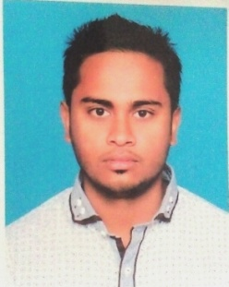
Resumre
0f
Md.Sakib Ahmed
Email:sakibahmedcse@gmail.com
Cell:+8801742792138
Address of corrospondence
House No:10,Block-A,Shahajalal Abashik Alaka,Khalibari,Modinamarket,Sylhet
Career objective

To build a career whit an organization where my merit,sincerty will contribute the best to gain its desirable goals and want to be a result oriented personality who likes to pursue corporate success throught a team based management approach.

Education Status:

Title of awarded qualification :Bsc in Computer Science & Engineering
Result :Final Year
Institute : Metropolitan University,Sylhet
Title of awarded qualification :Diploma in Computer Engineer
Result :2.87 (out of 4.00)
Board :BTEB
Institute : Sylhet Polytechnic Institute ,Sylhet
Pass Year :2016
Title of awarded qualification :SSC (Humanities)

Result :GPA 3.96(out of 5.00)
Board :Sylhet
Institute :Boarder Guard Public School and College
Pass Year :2011

Skills Summary

Web Design ,Graphic Design(Photoshop)
Lenguage Proficiency

Writing & Speaking skill in communation in Bangla and English.
Self Assessments

Excellent communication & interpersonal sensibility ,proactive and self-motivated Energetic, honest,responsibility and sincere about time & work.
Biograpical information

Name :Md.Sakib Ahmed
Father’s Name :Md.Shamsul Haque
Moher’s Name : Mst.Diluara Begum
Date of birth :09/04/1995
Nationality :Bangladeshi
Religion :Islam
Gender :Male
Marital Status :Single
Permanent Address:House No:10,Block-A,Shahajalal Abashik Alaka,Khalibari,Modinamarket,Sylhet
Adjustments

Duplicate copies of all necassay certificates.
Acknowledgement

Thereby declare that the submitted information is trun & authentic; I have not concealed any facts or information.

Signature
Md.Sakib Ahmed

