Résumé 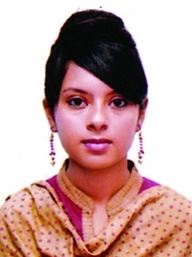

TASLIMA ZAFRIN TULY

taslimazafrin@gmail.com

Cell: +880-1732159978

Mitali-25/I, Khar Para, East Mirabazar, Sylhet, Bangladesh.

CAREER OBJECTIVE

I would like to work in an institution or organization where discipline and high tech environment will ensure development and will more skillful than other sector. I want to pursue a long term career, taking challenges and commitment to achieve result by working in a competent sector.

EDUCATION

Secondary School Certificate,2008
GPA: 4.94/5.00
Group: Science
Siraj Uddin Ahmed Academy, South Surma, Sylhet.

Higher Secondary Certificate,2011
GPA: 3.70/5.00
Group: Science
Sylhet Women’s College, Sylhet.

B Sc. in Computer Science & Engineering, 2015
CGPA: 3.78/4.00
Metropolitan University, Sylhet, Bangladesh.
Thesis Title: . A Rule-based Stemmer on Bangla Language

Thesis summary:
Deriving the appropriate base word for any given word in Bangla is one of the biggest challenges for language processing criteria. The basic concept to the solution of the problem is to eliminate inflections from a given word to derive its stem word. Stemmers attempt to reduce a word to its root form using stemming process, which reduces an inflected or derived word to its stem or root form. This research develops a rule-based suffix stripping algorithm that eliminates inflections and search for the tokens with exceptions in the dictionary.

SKILLS

I am skilled on the following programs:
- Programming Languages: C, C++, Python.
- Web Designing, Web Developing.
- MS Word, MS PowerPoint, MS Excel.

PERSONAL INFORMATION

Father’s Name : Nizam Uddin Ahmed
Mother’s Name : Shafia Begum
Permanent Address : Sreerampur, South Surma, Sylhet
Date of Birth | : 28th June, 1993
Religion | : Muslim
Nationality | : Bangladeshi
Marital Status | : Unmarried
Blood Group | : O-(ve)

REFERENCES

Md. Mujibur Rahman
Controller of Examinations
Shahjalal University of Science & Technology, Sylhet
Contact No: +8801718240829
E-mail: src_exam@sust.edu

Nazmin Akter
Senior Lecturer
Department of CSE
Metropolitan University, Sylhet
Contact No: +8801727053435
E-mail: nazmin@metrouni.edu.bd

