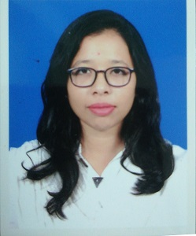
Shahajalal University of science and technology, SYLHET- 3114
01746339752
Nahar.mitu@gmail.com

Kazi khairun NAHAR
Objective |  | To pursue a challenging career with dedication and provide my efficiency to fullest in a professional organizational environment wherever I serve my duties that will discover the potential in me.
Skills & Abilities |  | Language: Fluency in Bangla and English  Communication: Comfortable in writing and speaking  Computer Literacy: Proficient at MS Excel, MS Word and PowerPoint, STATA.  Additional:  - Very good stress management  - Efficient at organizer  - Self-confidence and ability to transfer optimism
Experience |  | TEACHING ASSISTANT, BORDER GUARD PUBLIC SCHOOL AND COLLAGE.  JUNE 2017 – NOVEMBER 2017  DATA SURVEYOR, ASIAN CENTRE FOR DEVELOPMENT  It was a 7 days program. I have to collect data from 70 household. To collect data I use kobo toolbox app.
Education |  | Bachelor of Social Science (Economics) from Shahajalal University of science and technology with CGPA 3.54  HIGHER SECONDERY examination (science group) under Dhaka board from Dhaka City collage  SECONDARY examination (science group) under Comilla board from Noakhali Govt Girls high school.
Leadership |  | President, SUST school of debate ,2017-2018  Debate director, SUST school of debate,2016-2017  Tournament director at SUST INTRA –VERSITY National debate tournament 2.0 ,2018
achivement |  | CHAMPION;  Intra university women debate tournament organize by Jahangirnagar university,2014  RUNNERS UP; Tarunno intra university debate tournament organize by CUET,2015
CONTACT INFORMATION Shahajalal University of science and technology
SYLHET- 3114
01746339752
Nahar.mitu@gmail.com

I, the undersigned, certify that, to the best of my Knowledge and belief, this CV correctly describes me, my qualifications and my experience. I understand that any willful misstatement described herein may lead to disqualification or dismissal, if employed.

Kazi khairun nahar

