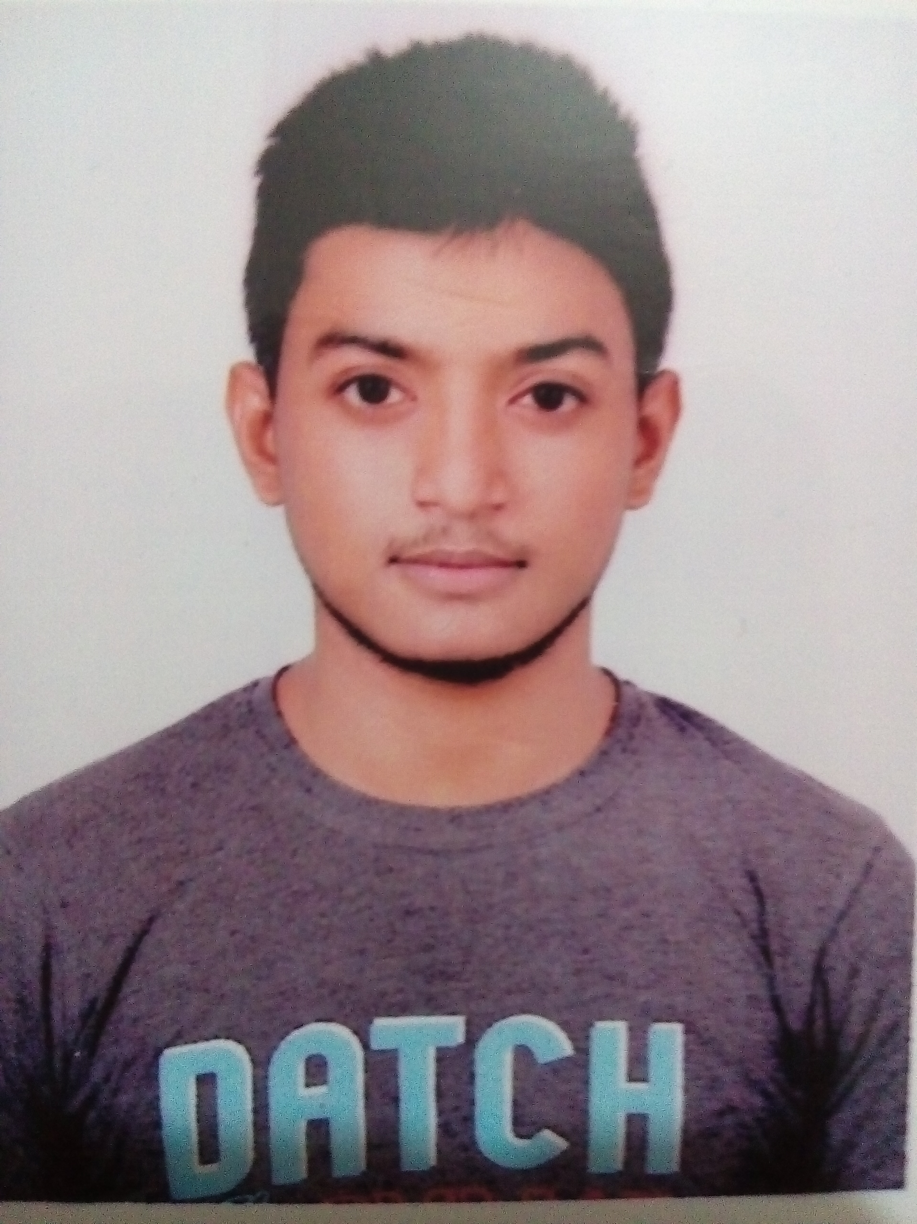
BOOTSTRAP and Basic JavaScript
HTML and CSS
MS Office (Word and Excel)
WordPress
Photoshop
Illustrator
Signature : Parvez
Dhaka – 1230.
A : H – 380, Faydabad, Uttara
Contact Info
Father’s Name : Ruhul Amin
Sex : Male
Dath of Birth : 29 / 09 / 1997
Nationality : Bangladesh
Religion : Islam
P : 01766118094
E : parvezrabbi664@gmail.com
Language
English
Reading, Writing, Speaking

Bangla
Reading, Writing, Speaking
Skills
Looking forward to achieve a responsible and challenging career to work in a professional. I am a creative & highly ambitious Designer.
About
Education
Secondary School Certificate (S.S.C)
Wisdom School and Collage
Year : 2015
Uttara Dhaka – 1230.
Diploma in Computer Science
Uttara Polytechnic Institute
Year : 2015 - 2019
Uttara Dhaka - 1230
Personal Info
Parvez Rabbi
Curriculum Vita

