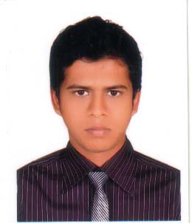CURRICULUM VITAE
Of
SINTHIA SH

Contact Address |  | Setu Chandra Ghosh. Cell # +88-01674-799890  House # 150 Email Address: setu_smuct@yahoo.com  Prembagan,Airport, Dhaka-1252.
Career Objective |  | To work in a multitask environment where good deeds are always appreciated which offers a competitive & performance based environment & nourish the talents. It would be a dynamic & challenging field where I can sit my full concentration & can explore my creativity & performance.
EducationalQualification  WorkingExperience |  | - Apparel Manufacturing Management & Technology (AMMT)  Subject : Merchandising.  CGPA: 3.70 out of 4.00  Institute:Shanto-Mariam University of Creative Technology.  - Higher Secondary Certificate(H.S.C)  Year of Award: 2008  Group: Business Study  GPA: 3.90  Institute:BikrampurTongibari Collage.  Dhaka Board  - Secondary School Certificate(S.S.C)  Year of Award: 2006  Group: Business Study  GPA: 4.63  Institute:Sonarong Pilot & High School.  Dhaka Board  Balaka Stitch PVT. LTD.(woven)  Junior Merchandiser.(1 year)  Hardy Associates Limited.(knit)  Internship in merchandising departmet.
ComputerKnowledge |  | MS Word  MS Excel  Power Point  CAD (Lectra)  Internet browsing and internet based applications
LanguageProficiency |  | I can write & speak in both Bangla & English.
Interest |  | Traveling, Photography, listening music, social activities and working in the challenging environment.
Motivation |  | Ready to work an active environment, under stress and enormous responsibility.
Area of mainInterest |  | Apparel Industry, Buying House, RMG related sector.
PersonalInformation | Name : Setu Chandra Ghosh.  Father's Name : ShudhangshuGhosh.  Mother's Name : Alo Rani Ghosh.  Present Address : 153 Prembagan,Airport, Dhaka- 1252.  Permanent Address : Tongibari,Munshigonj,Dhaka.  Date of Birth : 18 july,1990  Marital Status : Single  Nationality : Bangladeshi by Birth  Religion : Hindu
References |  | Mr. M FARUK MASUD  Head of the AMMT department.  SMUCT.  Mob: 01911317397
Certification |  | I the undersigned certify that the above information is true and correct to the best of my knowledge and belief.
Signature &Date |  | setu ghosh  Setu Chandra Ghosh

