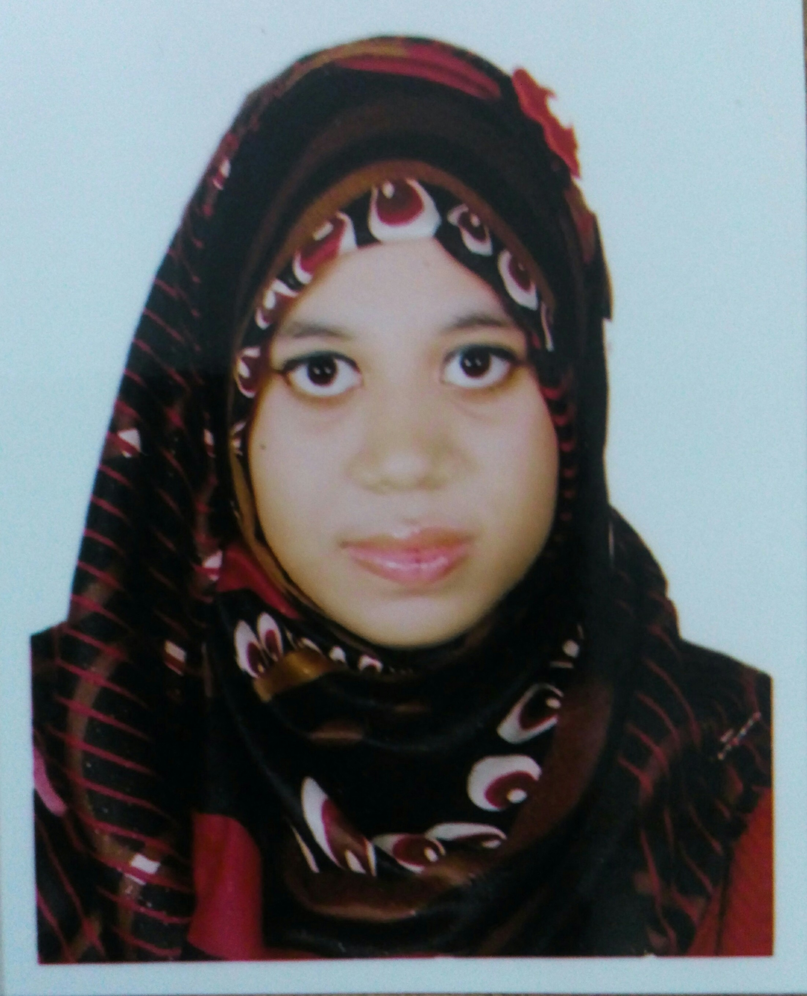
Curriculum Vitae of
AFSANA AMIN
Holding No:52;Somaj kollan Road,Dattapara,Tongi,Gazipur
Phone: 01750209726
Email: afsanaantora0@gmail.com

OBJECTIVE
To secure a position with a well-established organization with a stable environment that will allow me to apply my education and skills to the institution and be equally rewarded.

ACADEMIC CREDENTIALS

MASTER OF SCIENCE IN MICROBIOLOGY
Institution : Primeasia University
Year of passing : 2019
CGPA : 3.94
BACHELOR OF SCIENCE IN MICROBIOLOGY
Institution : Primeasia University
Year of Passing : 2018
CGPA : 3.92
HIGHER SECONDARY SCHOOL CERTIFICATE (H.S.C.)
Institution : Safiuddin Sarker Academy
Group : Science
Year of Passing: 2013
Result : 4.70
Board : Dhaka

SECONDARY SCHOOL CERTIFICATE (S.S.C.)
Institution : Shahajuddin Sarker Higher Secondary School
Group : Science
Year of Passing: 2011
Result : 5.00
Board : Dhaka

TRAINING
- Industrial Training held at IBN SINA Pharmaceuticals Ltd., Sofipur, Gazipur From 3th February,2018 to 14th February 2018.(major activities in this organization several microbiological test of raw and finished products, sterilization technique, sterile production like ophthalmic and injection ,general production like oral solid suspension ,liquid, activities of quality control, clean room system, water treatment)

● Research on Characterization and Identification of biosurfectant producing organism
from Oil contaminated soil sample at National Institute of Biotechnology(NIB)
,DhamsonaAshulia, Savar,, Sreepur - Kashimpur Road. From 8th February 2018 to 8th
May 2018

- Seminar on “Overview & Safe Use of Laboratory Ventilation Equipment, (Laminar Air Flow, Biosafety Cabinets and Fume Hood)”.

LANGUAGE PROFICIENCY
- Mother Tongue : Bangla
- Other language : English
LABORATORY SKILLS
- Identification of bacteria using microscopic and biochemical techniques, Maintaining and preserving the bacterial culture.
- Enrichment technique, screening test, DNA extraction, PCR, Agarose Gel Electrophoresis.(at NIB ,Savar)
- Determination of quantitative viable cells by serial dilution techniques (spread plate and pour plate).
- Gram staining.
- Media preparation and sterilization techniques.
- Techniques for isolation of pure cultures.
- Antimicrobial sensitivity test of microorganisms (qualitative).

PERSONAL DETAILS
Name : Afsana amin
Father’s Name : Md.Aminul Islam ( Ex Senior Engineering officer of Beximco Pharma
Senior Manager Engineering,IBN SINA Pharma)
Mother’s Name : Rebeka Parvin
Present Address : Holding No:52;Somaj kollan Road,Dattapara,Tongi,Gazipur
Permanent Address : Vill:Nowadaboga; P.O: S A College Thana:Sonatola: Dist:Bogura
Date of Birth : 03 March,1996
Nationality : Bangladeshi
Religion : Islam
Gender : Female
Blood Group : “B” negative(-ve)
Marital Status : Single

REFERENCE

Reference: 1
Name :Dr. SuvamoyDatta
Designation :Professor and Head;
Department of Microbiology
Institute :Primeasia University
Mobile No :01755-548324
Reference: 2
Name : Tanzina Akter
Designation : Scientific Officer
Institute : National Institute of Biotechnology
Email : tanzinaakterju@gmail.com
Mobile No :01681-466870
I hereby declare that all the information stated above are correct and complete to the best of my knowledge
Signature


(Name; Afsana amin )

